Writing Ideas for Home

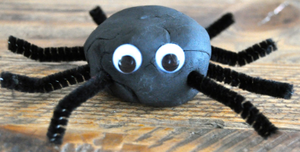
- Build castles out of flour, sand or soil. You could try using shot glasses instead of buckets to make lots of mini castles.

- Make different animals with playdough and items you can find around the house.

- Try a colour or paint by number activity.

- Decorate cakes or biscuits with icing.

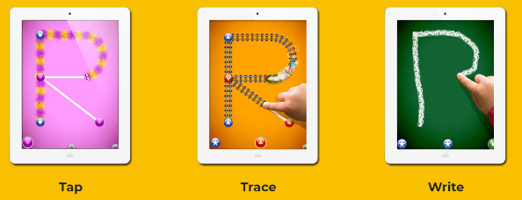
- Type your favourite songs or things into the Google or YouTube searchbar. You can write down the word they need in capitals so your child can find the right letters on the key board.

- Try out the letterschool app.

- You could tracing pictures or letters.

- Practice drawing lots of different shapes, cut them out and make different people and animals out of them.

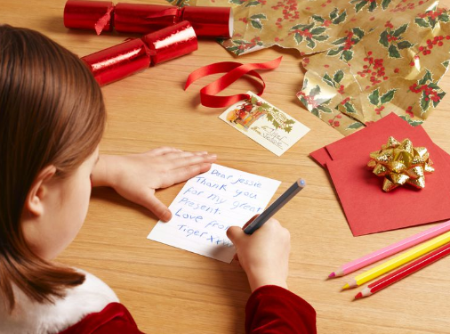
- Develop your child’s fine motor skills by building with lego or threading pasta or corron reels on a shoe lace.

- Write greeting cards to your friends and families, sign your name if you can, or copy out the whole message. Decorate the cards with stickers and stamps.

- Take a look at Twinkle.co.uk they have some fantastic resources that use colourful semantics. This is a colour coding strategy used in school to help children put words in the right order to build a sentences.

