Reading Ideas for home

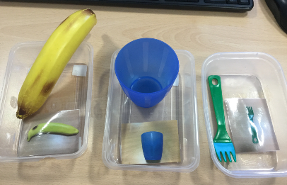
- ​Take photos of everyday objects around the house and match the photo to the object.

- Visit your local library if you can and explore any touch and feel books, lift the flap books or those with interactive sound buttons.

- Make up your own story sacks with objects you can find around the house to bring books to life. You could use decorated paper plates or soft toys to represent characters and any play materials you can find.
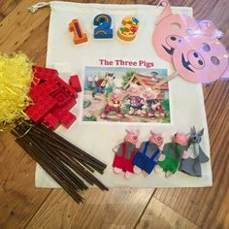
- Bring familiar stories to life by offering sensory experience e.g. read we are going on a bear hunt and then repeat the familiar rhymes while outside exploring grass, mud, water etc.

- Spend time looking at photo albums and photo books together, encourage your child to turn the pages and spend time looking at the pages

- Make up your own photo scrap book of activities you do together
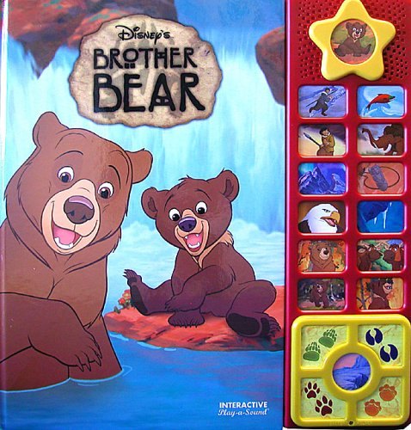
- Show photos to your child when you go somewhere or do an activity. Encourage your child to point to photos to make choices.

- See the Read Write Inc - Phonics information sheet for more ideas to promote early phonics skills

Sharing books

- Sharing books with children is a good way to develop their talking. It also develops their attention and listening skills.

- You don’t have to read all the words, just look at the pictures together and talk about what is happening.

- You can talk about the stories and characters in books even when you are not looking at a book.

- Looking at books helps to develop children’s vocabulary.

- Re-reading favourite books helps children to become familiar with the story and they can anticipate the ending.

- Books with rhymes help children’s awareness of rhyme which is an early skill that helps reading skills.

- Make story times fun by using props and puppets. You can also get the children to act out the story after you have read it.

