Indoor Gross Motor Sensory Play Ideas
These fun games are perfect for indoor gross motor sensory play! Simple to set up and great for getting out extra energy. Do you have a gross motor, sensory seeker? Do you have a VERY active child? I do, so I created these super easy indoor gross motor sensory games. We can enjoy these gross motor sensory games anytime! For some different variations also check out our line jumping and tennis ball games too!
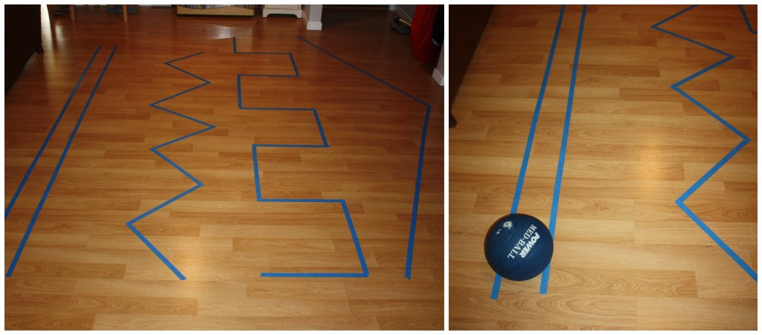

These games are extremely useful for children with sensory seeking needs!
All children will have fun with these gross motor sensory games. Grab a roll of painters tape, a heavy ball or object to push, and some plastic eggs. Move aside the furniture if you can to make a large space or just create one line!

What do I mean by Proprioception Input & Vestibular Sensory Play?
What is proprioception input? It is input from muscles, joints and other tissues that help to create body awareness. Jumping, Pushing, Pulling, Catching, Rolling and Bouncing to name a few are all common ways to do this! What is vestibular sensory input? It is all about movement! Some movements in particular like swinging, rocking, are hanging upside down are good examples!

6 Gross Motor Sensory Play idea for these lines!
Create as many lines as your space allows using different angles for each one!

1. Walking the lines heel to toe and however else is fun!
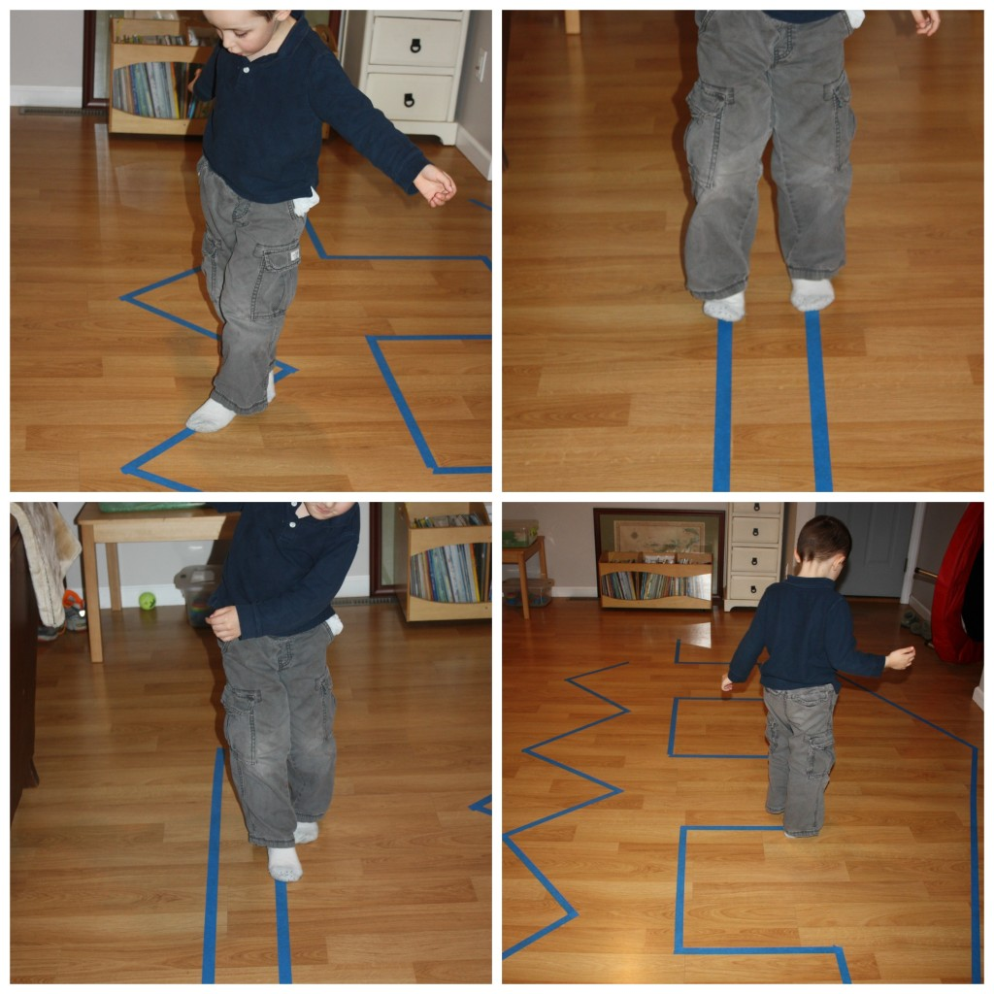

2. Jump the lines different ways and twist the body to move around the lines!
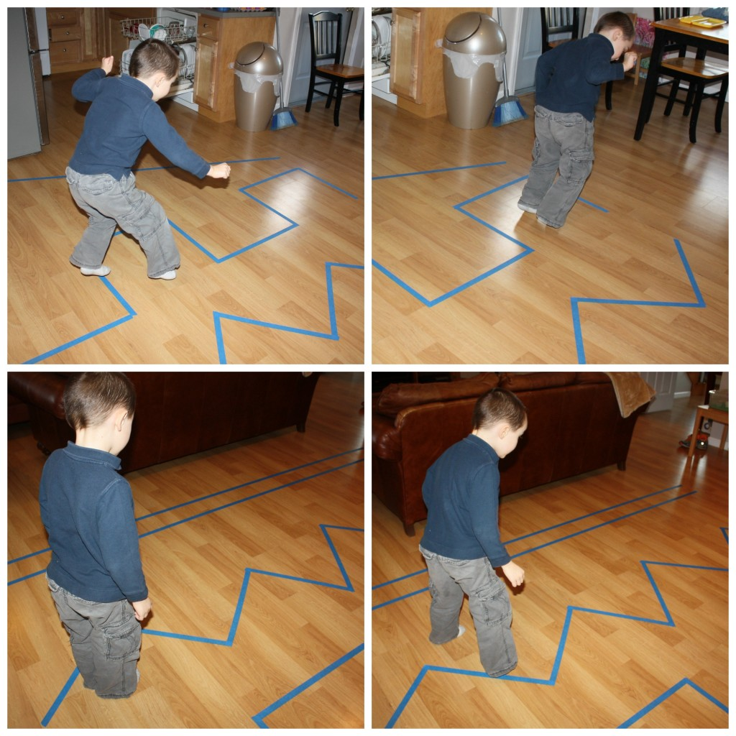

3. Roll the weighted medicine ball over the lines! Our you can push a weighted object such as a small container filled with soup cans. You may want to put a dishtowel underneath, so it slides easier
