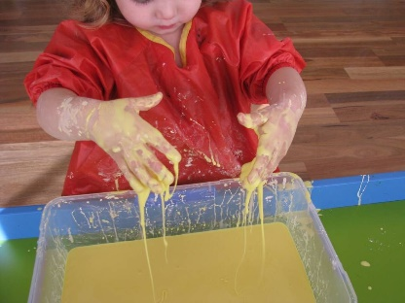
Writing Ideas for Home

- Make marks in different materials e.g. mud or flour

- Explore different textures as part of messy play

- Use a paintbrush and water and make marks on walls, fences and patios
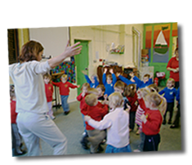
- Practise fine motor skills by exploring wind-up toys or using tongs

- Make different shapes with your body e.g. make circles with your arms or lines by moving arms up and down

- Practise colouring and scribbling but don't worry about staying in the lines

- Empty the dishwasher together and practise matching and sorting the cutlery.

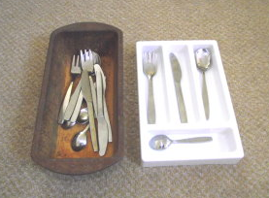
- Try rolling out playdoh/ salt dough/ cookie dough and using cutters. You could even try making different letters using playdoh.

- Do the dough disco https://www.youtube.com/watch?v=i-IfzeG1aC4​

- Try using your pincer grip to hang out the washing on the line. You could also pair up the clean socks together.

- Try threading pasta tubes onto straw or shoelaces and make necklaces.

Finger gym ideas

- Use padlocks and keys – how quickly can the children unlock them?
- Clothes pegs. How many can the children peg around a box in 1 minute? Which child can peg the most if playing against a partner etc
- How many small beads can children pick up in a minute with tweezers?
- Have mixtures such as dried pasta and peas. Can they separate the mixture using only tweezers?
- Scissor activity booklet – ensure children have correct scissor grip at all times.
- ‘Melt monsters’. Draw monsters with felt tip pens and then using eye droppers drip water on them and watch the monsters ‘melt’.
- Playdough (see over for recipe). Encourage the children to pull, squeeze, roll, twist it etc. Sometimes using the palms of their hands, othertimes using their fingertips. They can also prick out designs using toothpicks in the dough.
- How many bubble wrap bubbles can they pop?
- Threading beads onto a string
- How many paper clips can they join together?
- Have a simple outline drawing, children to stick string/wool onto these outlines.
- Play games that encourage strength in the shoulders eg: wheelbarrows, crabs, wall push ups etc
- Use individual hole punch round a piece of card. Children can then thread wool/ribbon through these.
- Play games such as tiddly winks or the frogs where you press their backs.
- Doing up buttons and zips quickly.
- Upright surfaces promote fine motor skills so do things such as painting on easels, writing on chalk boards/whiteboards etc.
- Pegboards
- Scrunching up sheets of newspaper with 1 hand (to then stuff something with eg: a scarecrow)
- Play board games requiring children to turn over cards/counters BUT they cannot slide them to the edge of the table to do so.
- Tracing round stencils
- Using small hammers, bang golf tees into something like a pumpkin
- Taking lids on and off small Tupperware containers

Playdough recipe

3 cups of flour
1 cup of salt
3 tablespoons cream of tartar
3 tablespoons oil
3 cups of boiling water

To change colour just add food dyes. Essences can be added to change the smell or replace water with something such as coffee or replace flour with cocoa etc. Small objects such as sequins can also be added.

