Report Guide for Parents
December 2022
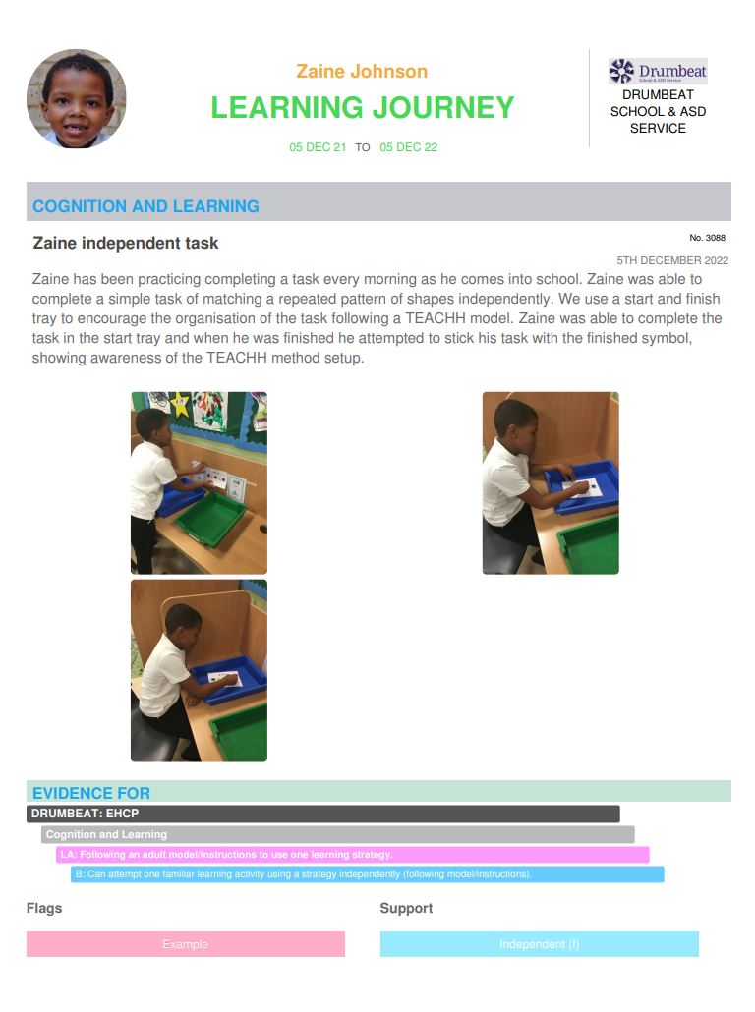
Report Information On your child’s report you will see:
Comment: This comment has been written by a member of the class team. This gives a brief explanation of what was happening at the time in relation to the child’s target on their learning map.
Title
Level of support given: please see support key attached
Marked as example for parent
Child’s personalised learning area that this evidence relates to and breakdown from learning map.
Curriculum that learning area comes from: ECHP or Drumbeat curriculum
Photo/child’s work

Photo/child’s work
Photo/child’s work

Subuct area
Dates
Photo curriculum
Child’s Name
Learning Map Information

Learning maps are now written in place of personalised plans. The aim of this is to ensure all areas of learning are captured in one place.
LA: (Learning area).
B (Breakdown) these are used to show the steps of progress a pupil will make towards the larger learning area.
The four top boxes are written from your child’s EHCP. Teachers will look at the area to be covered within the EHCP and then select a learning area from our Drumbeat Curriculum documents.

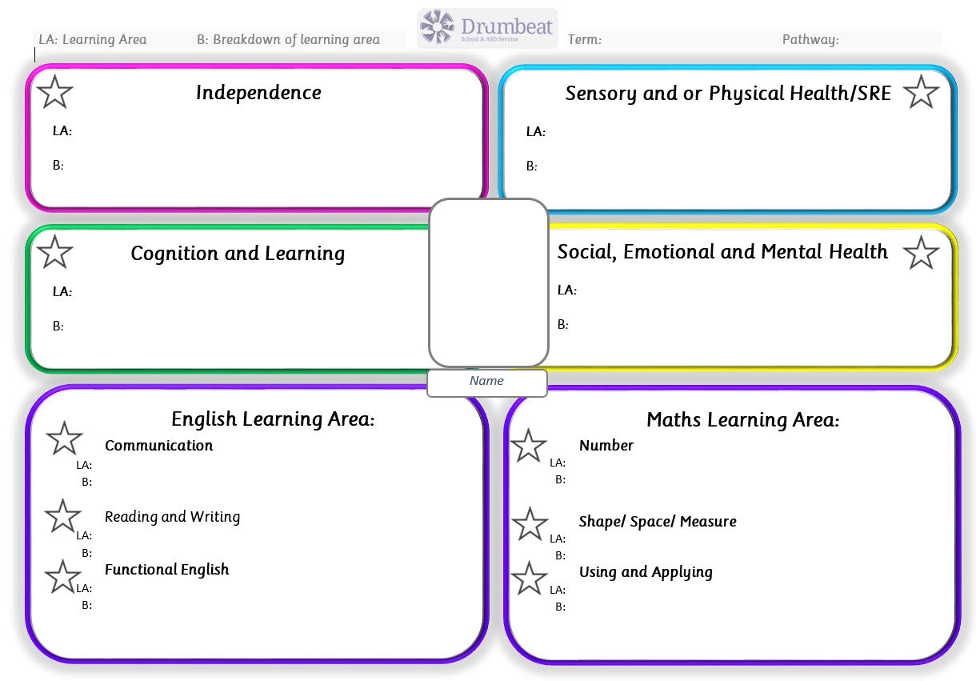
English and Maths learning areas are written from Drumbeat levels curriculum. Teachers look at what your child knows in this area and then chooses their next steps.
Stars on the learning map are coloured to indicate if your child has achieved this steps.
Green means achieved
Red means not achieved

Learning Map Information (Roots)

Learning maps are now written in place of personalised plans. The aim of this is to ensure all areas of learning are captured in one place.
The four top boxes are written from your child’s EHCP. Teachers will look at the area to be covered within the EHCP and then select a learning area from our Drumbeat Curriculum documents.
LA: (Learning area).
B (Breakdown) these are used to show the steps of progress a pupil will make towards the larger learning area.

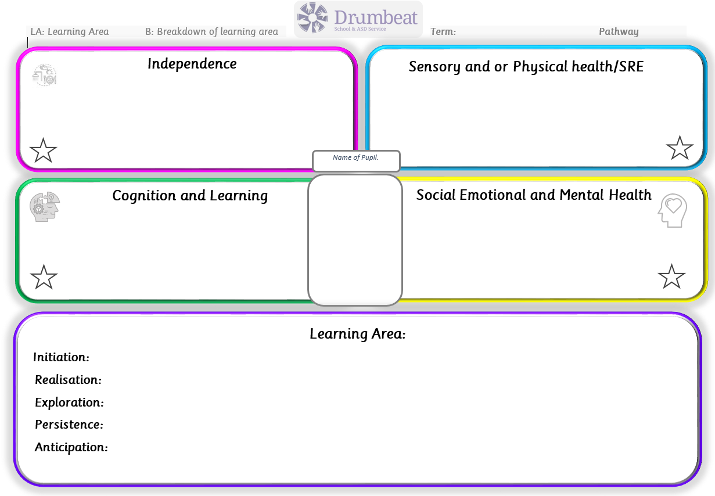
Learning areas in the purple box are written from the engagement model. These are the areas that teachers observe against to track your child’s progress.
Stars on the learning map are coloured to indicate if your child has achieved this steps.
Green means achieved
Red means still working on

Support levels
Full Physical Prompt (FPF)
Give substantial physical support to complete the task e.g. hand over hand

Model with corrections (MC)
Demonstrate an action or desired outcome e.g. video model or model in stage 4 AA task but then pupil needs modelling prompt repeated so they can correct their mistake

Model (M)
Demonstrate an action or desired outcome e.g. video model or model as in stage 4 AA task

Gestural Prompts with corrections (GPC)
Using gestures, pointing or Makaton signs to indicate where things need to go or what item is needed or what needs to be done (e.g. mix or open) and repeating these if mistakes are made

Verbal prompts with corrections (VPC)
Give direct verbal instructions to the student on correctly completing the task and needing to repeat or reword verbal instructions when mistakes are made.

Verbal prompts (VP)
Give direct verbal instructions to the student on correctly completing the task

Visual Prompts with corrections (VIPC)
The student uses visual instructions, equipment checklists or visual reminders given to them by an adult to complete the task correctly. (This does not include ‘behavioural’ supports such as first and then) but an adult needs to give additional support to refer the student back to the visual support when mistakes are made.

Visual Prompts (VIP)
The student uses visual instructions, equipment checklists or visual reminders given to them by an adult to complete the task correctly. (This does not include ‘behavioural’ supports such as first and then.)

Independent with corrections (IC)
The student aims to complete something independently, they could use natural cues or create their own visual supports to complete the task correctly e.g. writes down a list of equipment they need and what they are going do independently before carrying out a task. However an adult needs to provide some guidance when mistakes are made.

Independent (I)

The student completes something independently, they may use natural cues or create their own visual supports to complete the task correctly e.g. writes down a list of equipment they need and what they are going do independently before carrying out a task.

