What is school like Now?
I have been doing home learning for a while because of COVID 19 but I am getting ready to go back to school. When I go back to school some things will be the same as always and some things will be different for a while. Rules and routines will be different and rooms in my school may look different. These changes are to keep everybody safe and well. I know that it is important to keep everybody safe and well and that these changes are not for ever, they are just for now.

Here are some things that will be the same:
My school has the same name and is the same building
I will go back into the same year group
I will probably have the same head teacher
Lots of the teachers and support staff will be the same
I will still do my learning and have time to play in school
I will be able to see friends
I will still be able to talk to adults that I know

Here are some things that may be different:
I will have less children in my class
I will have less furniture in my class
I may have a different teacher and helper
I will have a shorter school day
I may come to school and leave school at different times to other children
I may have to use a different entrance and exit
I will have to have a packed lunch
I cannot touch others

In school we will have a visual timetable to help us know what is happening, which adults are in my class each day and what we are going to do. Not all my friends are going to be in the class at the same time. I will be with children in my class but not my whole class. This will help to keep everybody safe and well. This new routine is for now, it is not for ever.

My New School day is Different
My school day will start at ---------------------------------------------------
My school day will end at ------------------------------------------------------------
I will come to school on-------------------------------------- (these days)
My classroom will be -------------------------------------------------- (or photo)
My teacher will be ______________________ (or photo)
The helpers in my class will be ------------------------- (or Photo)
I will enter school from this entrance (insert Photo)

I will leave school from this exit (insert photo)

I will play in this playground at playtimes (insert photo)

I will have a packed lunch every day and I will eat this in ___________(or photo)

These new routines are for now to keep everybody safe. They are not for ever, just for now.

What are the New School Rules To help everybody stay Safe and Well
When I go back to school there will be new rules and routines to learn. There will be things that we are not allowed to do for now to keep each other safe and well. These are the red rules. I will try not to worry about these new rules and routines as they are new to everybody and it will take some time for us to learn them and get used to them. We can try the new green rules instead.

I will try not to… | Instead I can…
Touch anyone.  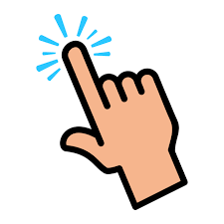 | I can wave hello  I can say, ‘it’s good to see you’  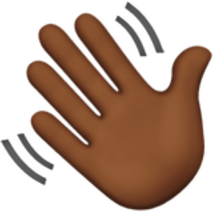  It’s good to see you
Hold hands  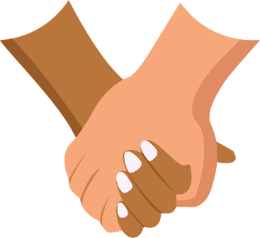 | I can walk next to my friend keeping a safe distance (two metres)  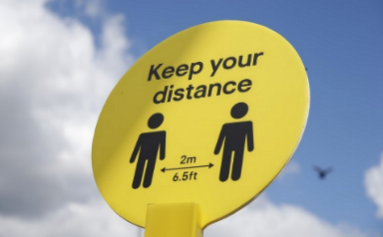
Hug my friends  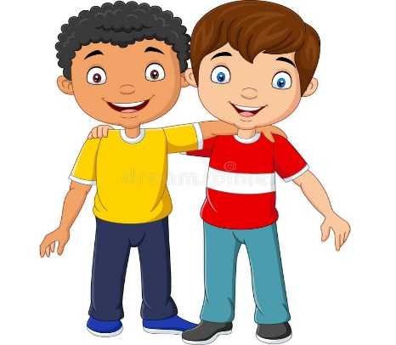 | 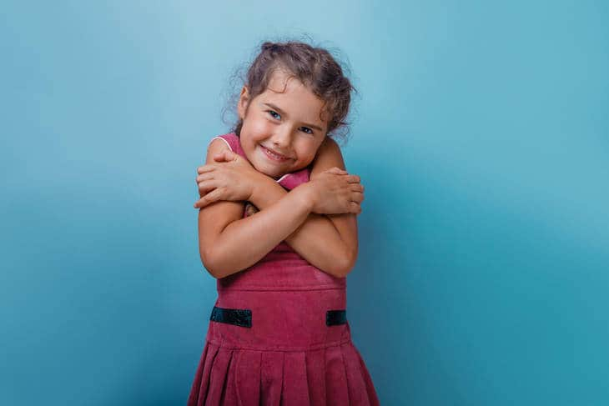  I can look at my friend and give myself a hug.  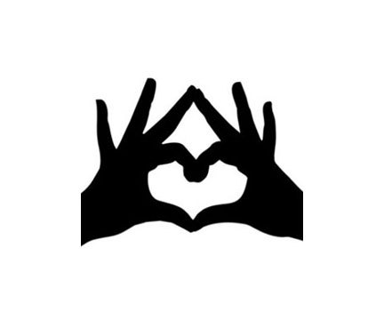  I can make a heart emoji sign to my friend
Touching In School
There are many new rules in school. There are things we cannot do for now to keep each other safe and well. An important rule is about touching others. We have to learn to keep a safe space around us in school. Adults call this social distancing. We have a new rule about keeping a safe space in school. This will help us to remember social distancing.
We can help ourselves remember the safe space rule like this. We can lift up our arms and stretch them out to the sides. We can twist around with our arms stretched out. This shows us the safe space all around us. We will try to remember that everybody needs to have this safe space around them to keep everybody safe and well.
When I am doing my learning in class I will try to remember the safe space rule. I can stretch my arms out to show others my safe space.

When I am playing in the playground I will try to remember the safe space rule. I can stretch my arms out to show others my safe space.

When I am coming into school and going home from school I will try to remember the safe space rule. I can stretch my arms out to show others my safe space.

If I forget the space space rule and accidently touch someone, it’s ok I can wash my hands and they can wash their hands. This will keep everybody safe and well.

Remembering the safe space rule in school will help us to follow the social distancing. This rule is for now. It is not for ever.
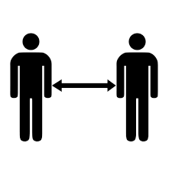
Keep a safe space

