Pathway 1 Activities:

Everybody do this

Skills being developed: Attention, creativity, gross motor and creativity

Sit together in a circle or across from one another.

Recite the chant “everybody do this do this do this, everybody do this just like me” whilst doing a simple action/gesture over and over again,

For example;
- Clapping
- tapping your knees
- waving your hands

Encourage your child to copy you if they are not already doing so, and continue to chant as you repeat the action over and over.

Repeat a few times over with different actions.

Next, ask your child to make up an action as you/they chant. If they do not make a specific action, try to copy something they are doing in order to show that it is their turn and they are in control.

Don’t forget…
Help your child in whatever way they need, remind them it is ok to make mistakes, and reward their efforts with praise and positivity!

Down at the Zoo

Skills being developed: Attention, creativity, rhythm and animals

Sit together in a circle or across from one another.

Start a rhythmic pattern of clapping your hands, then patting your hands on your lap, over and over fairly slowly. Encourage your child to join in.

Chant in time with the rhythm:
“down at the Zoo, feel the beat on your feet,
think of an animal that you’d like to meet”

Stop the clapping/patting beat and ask your child to pick an animal they’d like to meet (using pictures of animals to provide suggestions if needed) and do an impression of that animal for them. Include noises, movements and facial expressions in your impressions. Get as creative as you like – make it FUN.

Start the clapping/patting rhythm again and repeat the chant. Encourage your child to choose a different animal this time.

After a few rounds, swap roles and Ask your child to recite the chant (either alone or with support), and you tell them what animal you would like to meet and they do the impression.

Variations – things to try:
- Show pictures of animals (from a book/phone/tablet) to aid this activity.
- Do the impressions of each animal together as a group.
- Ask your child to do an impression of an animal as a way of answering “what animal would you like to meet?” and see if you can guess.
- Change the chant to: “Down at the Farm” so that a new group of animals can be acted out.

Don’t forget…
Help your child in whatever way they need, remind them it is ok to make mistakes, and reward their efforts with praise and positivity!

Ways to move

Skills being developed: Attention, creativity, gross motor and physical awareness.

This activity can be done in the garden or in an open space indoors (eg. Living room) – it does not need to be a big space, but useful to not have any small objects on the floor that you could trip over.

Stand in the space and say “we are standing still”.

After a few seconds say “let’s walk”, and begin to walk slowly around the space, either in a random direction or in a circle if you prefer. If needed – hold your child’s hand or guide them with one hand on their shoulder.

Next, say “let’s skip”, and start skipping around in the space. Help/show your child how to move in that way where needed.

Repeat this instruction using any of the following ways to move:

Running
Crawling
Rolling
Hopping
Jumping
Leaping
Tip-toeing
Walking backwards
Walking slowly
Walking fast
Walking quietly
Walking loudly

Feel free to add your own ways to move to this list – be as creative and silly as you like, make it fun!

Don’t forget…
Help your child in whatever way they need, remind them it is ok to make mistakes, and reward their efforts with praise and positivity!

The Alphabet Game

Skills being developed: Reading and communication, improvisation, attention and creativity.

Sit across from your child or together as a group in a circle.

To start, say “A” (if possible, show your child the letter written down either on a piece of paper or on your phone/tablet). Then say “A is for Apple”, and immediately act out picking up an imaginary apple and biting into it. Include as many sound effects, facial expressions and emotional responses eg. “mmm yummy!” as possible.

Next, say “B”. “B is for ball”. Act out bouncing/kicking an imaginary ball.

Once your child has seen you do a few letters, tell them it is their turn. If your child is verbal, encourage them to say the letter, what it is for, and then act it out. If your child is non-verbal, say the letter, eg. F, and then say “F is for…” and see if they act anything out.

If this is difficult for them, complete the sentence, eg. “F is for Fish”, use your hand to imitate a fish swimming through the water, and encourage them to copy you – use your hand over the top of theirs if required.

Continue to go through each letter of the alphabet taking turns with your child. Give them as much help as they need to come up with ideas or to think of how best to act it out.

Keep it fun, and only keep going as long as they can – you do not need to finish the whole alphabet!

Variations – things to try:
- Ask your child to tell you what the letter is for, regardless of whose turn it is.
- After saying the letter, eg. “M”, say “M is for…” and then act out the letter (eg. Pretending to be a monkey) and ask your child to guess what “M” you are being. You can then swap and ask your child to act out a letter and you have to guess what they are.
- Categorise the game; eg. by saying whatever you choose it must be an Object (apron, ball, car), Action (aim, blow, cry), Food/drink (apple, banana, crisps). This can help your child to think of a word by narrowing the field, and keeps the game fresh and varied.

Don’t forget…
Help your child in whatever way they need, remind them it is ok to make mistakes, and reward their efforts with praise and positivity!

Real world role-play

Skills being developed: Attention, communication, improvisation, creativity, and understanding of the world around us.

This is a structured and guided pretend game where the goal is to act out scenarios that your child will encounter in real life.

This activity gives you the opportunity to practice routines in the day, teach how you would like you child to do certain tasks, or how you would like them to cope with certain situations in a creative and FUN way.

Find a clear space in a room in which you will “act it out”.

Firstly, think of a part of your child’s day, or situation that they will be familiar with. For example:

- Getting up in the morning
- Having a bath
- Going on a car journey
- Trip to the shops
- Dinner time
- Meeting a friend/relative.
- Going for a walk

Once you have chosen (keep it as simple as possible to begin with). Tell your child “Let’s play pretend – we are going to …” and tell them what you will be acting out.

Be enthusiastic about the idea and remember that you will have to lead the way.

Begin to act out the scenario/situation with your child. This is easiest done if you take on the role of ‘narrator’ as well as actor, and talk them through the ‘scene’ as you go.

Here is an example of what you might say and do if you are pretending to
“go for a walk”:

How exciting! It’s time to go for a walk. What do we need first? I know – our coats (pretend to pick these up and put your and theirs on). What next? Ah yes – our shoes (pretend to put these on). Have I got my bag and keys? (look around for them and pick them up). Ok, here we go. Out of the door (pretend to open the door, step through it and close it). What a lovely day for a walk (hold your child’s hand and walk on the spot OR round in a circle in the room). Oh look at the lovely flowers (point to the side), and look at the dog going for a walk (point to the other side). What can you see? (if your child is verbal, see if they can tell you what they see when out for a walk). Ooo, it’s getting windy (pretend to do up your coat and sway around a bit in the wind). Wait! Oh no! It’s started to rain (look up to the sky, put your hand out as if feeling the rain). Oh dear, it looks like we will have to go home (turn around and walk in the other direction and pretend to walk home). Never mind, we can go for a walk again tomorrow instead (keep walking fast and mime unlocking the door and going inside). Oh look! We’re all wet (touch your pretend clothes). Let’s get out coats off (pretend to take them off and shake them out), oops I’m getting water everywhere! Let’s go and warm up inside (walk to sit down on the floor or a chair for a cuddle, or pretend to sit down under a blanket).

This is just an example – ensure to make the scene relevant to your child and add in any bits that are personal to yourselves. The important thing is to keep it fun and not too long or complicated.

Variations – things to try:
- Include props, eg. Invite your childs’ toys to join you for dinner, or bring a sponge down from the bathroom so they can pretend to take a bath.
- Get creative – yourself and your child could do sound effects in the scene or sing songs.
- Try asking your child to pretend to be someone else in the scene, eg. ask them to be the sales assistant in the shop.
- Extend the activity by purposefully ‘getting it wrong’. For example, put your shoes on your head when pretending to get ready to go out. This adds humour to the scene and gives your child a chance to correct you. If they don’t spot the mistake, point it out to them and say “woops, I’ve put my shoes on my head – oh dear! They should be on my feet!”
- Extend the activity by adding in some dramatic and fun twists – eg. Oh no! An elephant has decided to join us in the car! Or, “Oh no! We’ve come out for a walk and suddenly there’s a storm!”

How much help your child needs will vary, and different “scenes” will be more of a challenge than others. If needed, hold their hands and guide them through the scene, give them verbal support by talking them through what to do, or simply give them prompts if they get stuck. Make sure you join in and pretend with them the whole way through – unless they ask you to let them perform it/parts of it to you.

Encourage your child to join in and add bits in themselves if they like, or even take the lead, but ultimately how much your child participates does not matter – it’s the experience and enjoyment that counts, and just by paying attention and being part of it they will be developing skills and learning.

Don’t forget…
Help your child in whatever way they need, remind them it is ok to make mistakes, and reward their efforts with praise and positivity!

Visuals for activities below

If you have any questions regarding any of the activities or would like any help/suggestions, please email me at j.murrell@drumbeat.lewisham.sch.uk

Enjoy!

Julia (Instructor)

Pathway 1 Activities:
VISUAL AIDS

Everybody do this

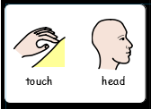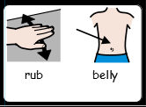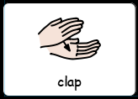

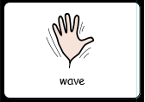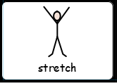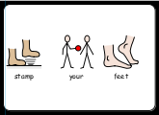

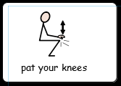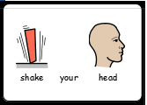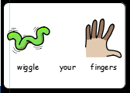

Down at the Zoo

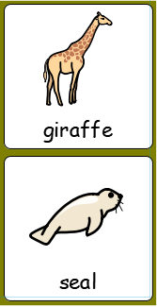
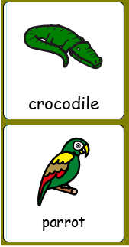
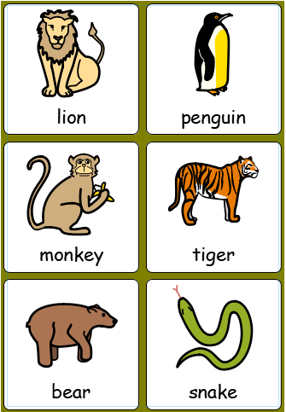
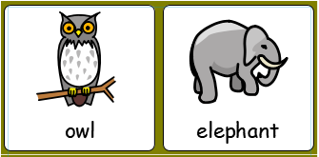

Ways to move

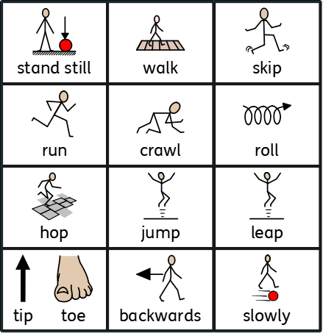
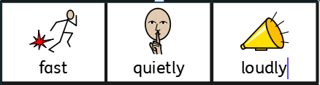

The Alphabet Game

A | B | C | D | E | F
G | H | I | J | K | L
M | N | O | P | Q | R
S | T | U | V | W | X
Y | Z

Real world role-play

