TALKING TEENS

**Family Thrive Early Help Co-ordinators are running a free course for parents or carers of teenagers and pre-teens who are looking to better understand and communicate with them – It offers an opportunity to understand what’s going on in the adolescent brain and how to understand their feelings and behaviours using an authoritative parenting style. Sessions will focus on relationships within the family, communication, negotiation, decision-making and strategies to reduce conflict.**  
  
**The group aims to develop:**

* relationships between teenagers and parents/carers
* a calmer home life
* confidence when talking about difficult issues
* an understanding of teenage needs and development

**Who would be eligible to attend this course?**

* Parents and carers of pre-teens and teenagers who are currently in years 6 & 7 but there may be availability for years 5 & 8
* There is no physical or extremely challenging behaviour present in or outside of the family home. This course focuses on the importance of empathy and positive discipline
* Family must reside in Lewisham borough or child must attend a Lewisham school

**How long is the course?**

* 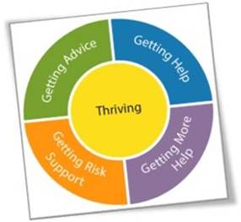Each group is 4 sessions over the course of 4 weeks
* 2 hours per session (10.00am-12.00pm on Thursdays)

**For more information or to register your interest, please email our duty box: EHCFamilyThrive@lewisham.gov.uk**