HOW TO STAY SAFE

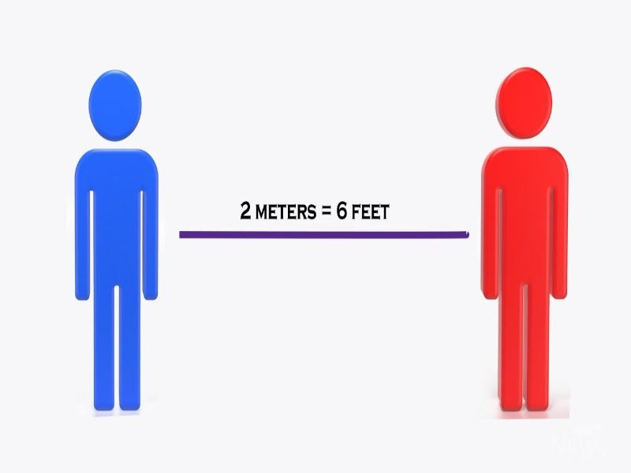
Stay 2 metres away from teachers and other pupils

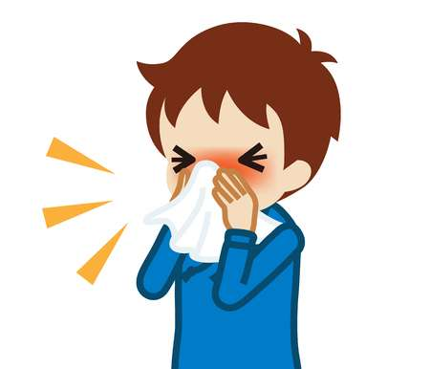
Sneeze or cough in a tissue.

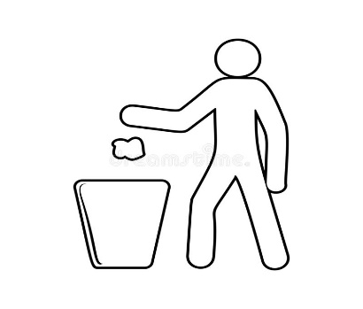
Throw the tissue in the bin.

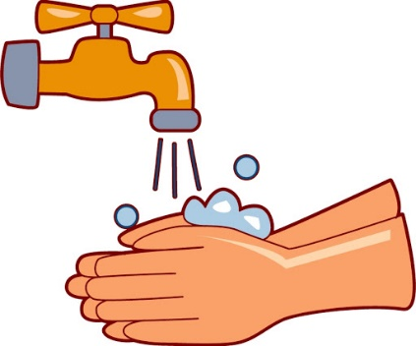

Wash your hands.

