Writing Ideas for Home

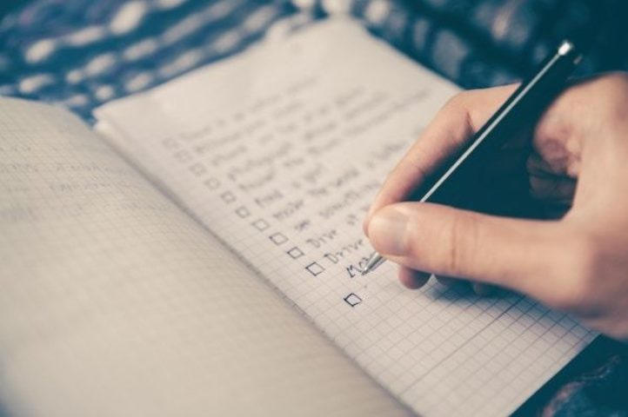
- Write a shopping list together

- Write a list of jobs that need to be completed for the day

- Watch a film or read a book together and write a review. Try to encourage your child to use capital letters, full stops and commas correctly.

- Each morning write out the day, date and describe what the weather is like

- Write or type a diary entry at the end of each day talking about what you did and if there was any information on the news the child found interesting. You could also print off any photos you have taken during the day and your child could write a caption under each one explaining what is happening.

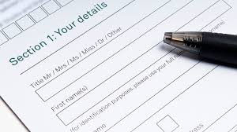
- Write or type a letter or card to a family member or friend you haven't seen in a while telling them what you have been doing and asking them questions

- Word of the Day: each day think of a different word, learn how to spell it, put it in a sentence, think of other words that mean the same thing and write a definition for the word.

- Write down as many fruits/ vegetables/ toys/ vehicles etc you can in 2 minutes

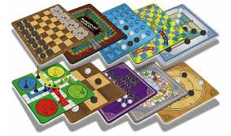
- Practise filling out personal information on forms

- Play a board game together and get your child write out instructions explaining how to play it.

- Write down a set of instructions explaining how to get to the local park or shop

- Try completing some of our worksheets below:

Choose the 2 best ‘wow’ words

A ______ house

- angry
- big
- sweet
- white
- plastic

A ______ puppy

- noisy
- ripe
- wooden
- cute
- hard

A ______ ball

- red
- skinny
- quiet
- round
- happy

The _______ floor

- nervous
- thick
- clean
- slippery
A ______ monster

- loud
- salty
- cute
- ugly
- shiny

A _______ orange

- brave
- clean
- sweet
- juicy
- slow

A _______ dinner

- yellow
- healthy
- clean
- yummy
- soft

A _______ car

- dirty
- cold
- old
- scared
- tall

A ______ story

- handsome
- wet
- quiet
- scary
- long

A _______ holiday

- short
- thin
- blue
- brave
- exciting

A ______ boy

- shiny
- round
- hungry
- handsome
- hard

A ______ apple

- crunchy
- purple
- cute
- long
- juicy

A ______ teddy

- salty
- cute
- soft
- slippery
- noisy

A _______ train

- dirty
- nervous
- hungry
- fast
- pretty

A _______ concert

- tall
- wet
- loud
- plastic
- great

________ news

- terrible
- fat
- slippery
- good
- thin

Make these sentences more exciting by adding describing words:

The _______ girl ate the _______ cake.

The _______ car was driving on the _______ road.

The _______ fish was swimming in the ________ fish tank.

The _______ pig was eating a ________ apple.

The ________ man was watching a ________ film.

The _________ puppy was jumping over the __________ fence.

The ________ house was sold to the _______ man.

The __________ monkey was eating a ________ banana.

The ___________ snake was sliding on the ____________ ground.

The ________ boy was drinking a _______ drink.
ADJECTIVES
Adjectives of Quantity. Choose the correct words.
- She has only (a few, a little) coins in her purse.
- Did you have to answer (much, many) questions?
- The beggar has (little, few) food to eat.
- The (three, two) boys are twins.
- There isn't (many, much) ink left in the bottle.
- He gave her (a few, some) money.
- Which of the (some, two) roads lead to the station?
- There are (several, little) cows on the small farm.
- He bought (much, many) meat from the butcher.
- We didn't buy (any, many) vegetables from the market.

Fill in the blanks with the following adjectives: little; wild; dark; angry; eight; muddy; honest; heavy; clumsy; much; proud; skinny; brave; narrow; blind.
- My mother is _____ of our new house.
- I cannot lift this _____ box.
- That _____ boy knocked down the vase.
- The thin beggar raised his _____ hand.
- The _____ soldier was awarded a medal.
- Cars are too big to use this _____ path.
- Tigers are _____ animals.
- He is poor. He hasn't _____ money.
- He is an _____ man. You can trust him.
- They helped the _____ man to cross the road.
- Look at the _____ sky. It is going to rain.
- They have broken the window. Their father is very _____ with them.
- There are _____ pints in a gallon.
- We have to take off our shoes. This path is _____.
- There is only a_____ water left in the bottle.
Preposition used after an adjective. Put in the missing words:
- Is he fond _____ tea?
- She is anxious _____ start.
- I was angry _____ him.
- He was pleased _____ us.
- She is keen _____ hockey.
- He is interested _____ flying.
- She is envious _____ them.
- That was foolish _____ you.
- It was expensive _____ buy.
- Is he worried _____ them?
- She was afraid _____ it.
- I was terrified _____ it.
- She was annoyed _____ us.
- He is sure _____ agree.
- He is prepared _____ go.
- I was patient _____ them.
- He was reluctant _____ go.
- He is very clever _____ his hands.
- She is good _____ dancing.
- I am tired _____ waiting.
- The accused man said that he was innocent _____ murder. The jury eventually found him guilty _____ manslaughter.
- She was silent _____ several minutes.
- His bicycle is quite different _____ yours.
- That was very convenient _____ us.
- They say that Albert is brilliant _____ football.
- She was excited _____ the news of her brother's success.
- We were both surprised _____ his conduct.
- She said, “I am disappointed _____ you.”
- I was puzzled _____ what he said.
- She was astonished _____ the unusual sight.
- He was exhausted _____ the tiring journey.
- His car was badly damaged _____ a lorry.
- It was easy _____ us _____ escape.
- It was difficult _____ us _____ find out where he lived.
- He was boastful _____ his success in the competition.
- Be careful not _____ cut yourself.
- Be careful _____ the traffic.
- The dancing was delightful _____ watch.
- This medicine can be harmful _____ young children.
- That was very courageous _____ him.
- It is dangerous _____ swim in that part of the river.
- He is famous _____ his backhand shots.
- My father is very suspicious _____ that man.
- Those shoes will be quite comfortable _____ her.
- It was most sensible _____ him to do that.
- He is active _____ several school societies.
- It's no good feeling sorry _____ yourself.
- It was wrong _____ him to say that.
- She looks worried _____ something.
- Try to make his stay here pleasant _____ him.

Choose the correct conjunction

I will run if/until I get tired.

I can not come unless/if mum says no.

We can go and play if/unless it stops raining.

I will be happy if/until you come to my party.

Unless/if we find treasure, we will be rich.

We have to wait until/if after dinner.

I am sad because/until Christmas is over.

We can not make a snowman unless/if it snows.

We will get wet unless/if you have an umbrella.

We won’t get lost because/unless we have a map.

We will get lost because/unless we have a map.

The football game was cancelled until/unless Saturday.

The juggler will drop a ball until/if you tickle him.

I won’t go home if/until I catch a fish.

The beach ball flew away because/unless it is light.

I will carry the books until/if my arms get sore.

I can lift the baby because/if I am strong.

He was laughing because/until the joke was funny.

If/Unless the snow stops, the roads will be closed.

I will pay for the movie because/unless I have money.

The captain was yelling because/if somebody lost the map.

The baby was crying until/unless her mum picked her up.

I will run until/if it is dark.

I will write a story unless/because I am busy.

The puppy needs a bath because/unless it is dirty

Connective gap fill quiz
Fill in the blanks with these words: although, and, because, but, or, since, so, unless, until, when.
Then make up your own sentence using this word.
1 Things were different __________ I was young.

2 Today there was no school _______________ it was snowing.

3 This is an expensive __________ very useful book.

4 You can’t go out to play football _______________ you have finished your work.

5 That was years __________ years ago.

6 She has not called __________ she left last week.

7 I saw him leaving an hour __________ two ago.

8 Let’s wait here __________ the rain stops.

9 We were getting tired __________ we stopped for a rest.

10 He was angry __________ he heard when happened.

11 Walk quickly __________ you will be late.

12. _____________ it’s a bit cold, we will still have a picnic.

13 We will go swimming next Sunday, __________ it's raining.

14 I heard a noise __________ I turned the light on.

15 Do you know __________ she will arrive?

16 __________ the car is old it still runs well.

17 Do you want a pen __________ a bit of paper?

http://www.bbc.co.uk/skillswise/words/grammar/interestsentences/compoundsentences/game.shtml

http://www.myenglishgrammar.com/english/exercise-3-adjectives.html

