Reading Ideas for home

- ​Share books with your child and act out familiar parts e.g. run away from the big bad wolf or grow like a beanstalk​ or use objects to retell the story

- Visit your local library if you can and find picture books that have one word on a page or a very short sentence. Read them together and look at the pictures, encourage you child to label things they can see in the picture or describe what the characters are doing.
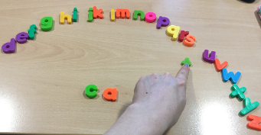
- If you have some magnetic or foam letters, play with them, put them in alphabetical order, see what words you can read and spell. You could always write out the alphabet and cut out each letter to do the same activity.

- Give your child a choice of which book they would like to read

- Read books with a repeated line or phrase in and see if your child can join in with this e. If your child is pre-verbal try recording the repeated line on your phone and encouraging your child to press play at the right time.
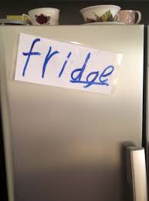
- Watch short stories on YouTube or the TV. Cbeebies bedtime stories have a great collection and many of Julia Donaldson's books have been made into a film and may be available on demand or Amazon Prime.

- Write out words of items in the house, cut them out and see if your child can match them correctly e.g. put the word 'bath' in the bath and the word 'chair' on the chair.

- Write the names of family members and see if your child can find their own name from your choices.

- Write out lots of different letters on pieces of paper and get your child to jump on/ run to/ hop to/ put a block on the one you say e.g. can you hop to the 's'? can you jump on the 'm'?
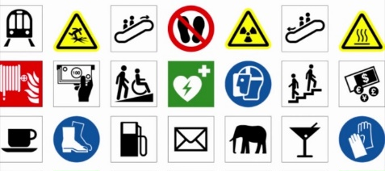
- Go for a walk and take photos/ talk about/ read all the signs and symbols in the environment e.g. bus stop symbol, toilet signs, fire exit etc

- Draw pictures and write key words when creating your shopping list and encourage your child to read it to you as you shop.
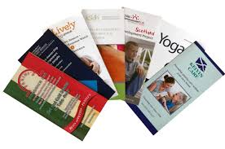
- Explore magazines and leaflets together looking at the pictures and reading the information.

- See the Read Write Inc - Phonics information sheet for more ideas to promote phonics skills

