To the Island
A Massage Story
by
Karen Richards
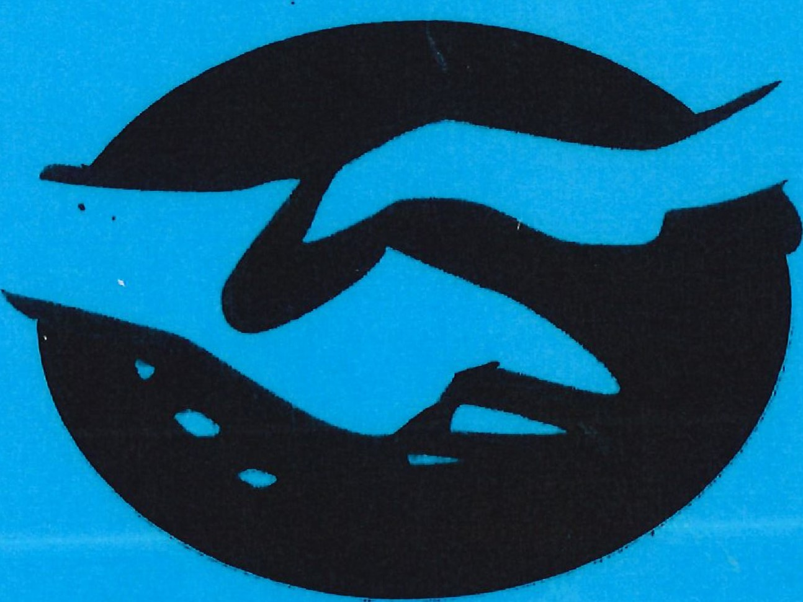
Thank you
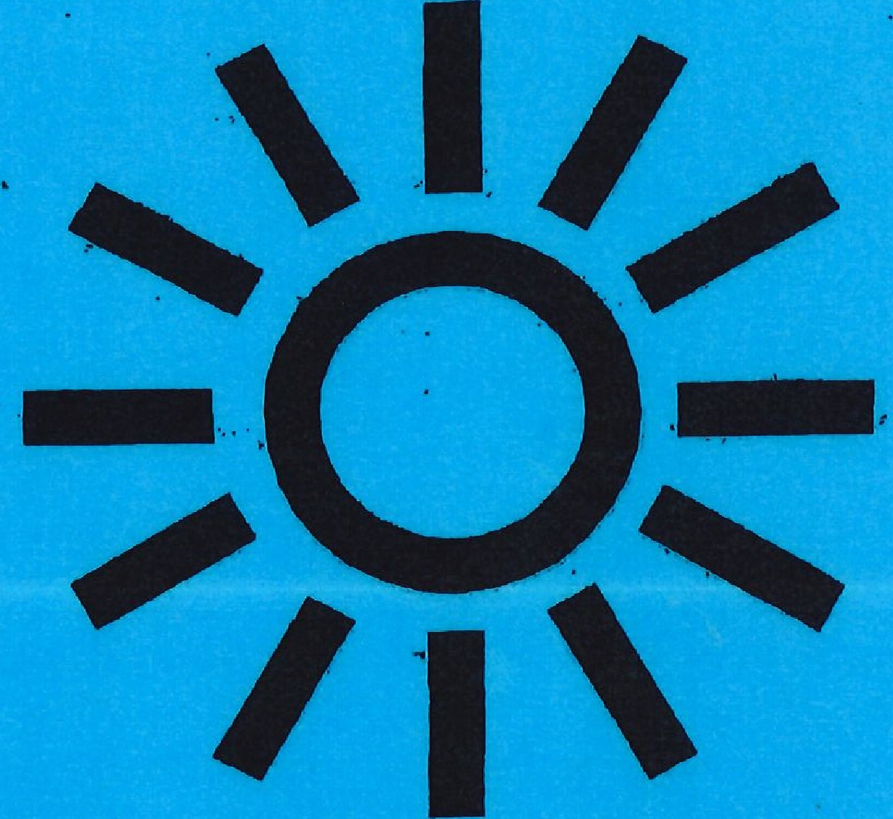
sun

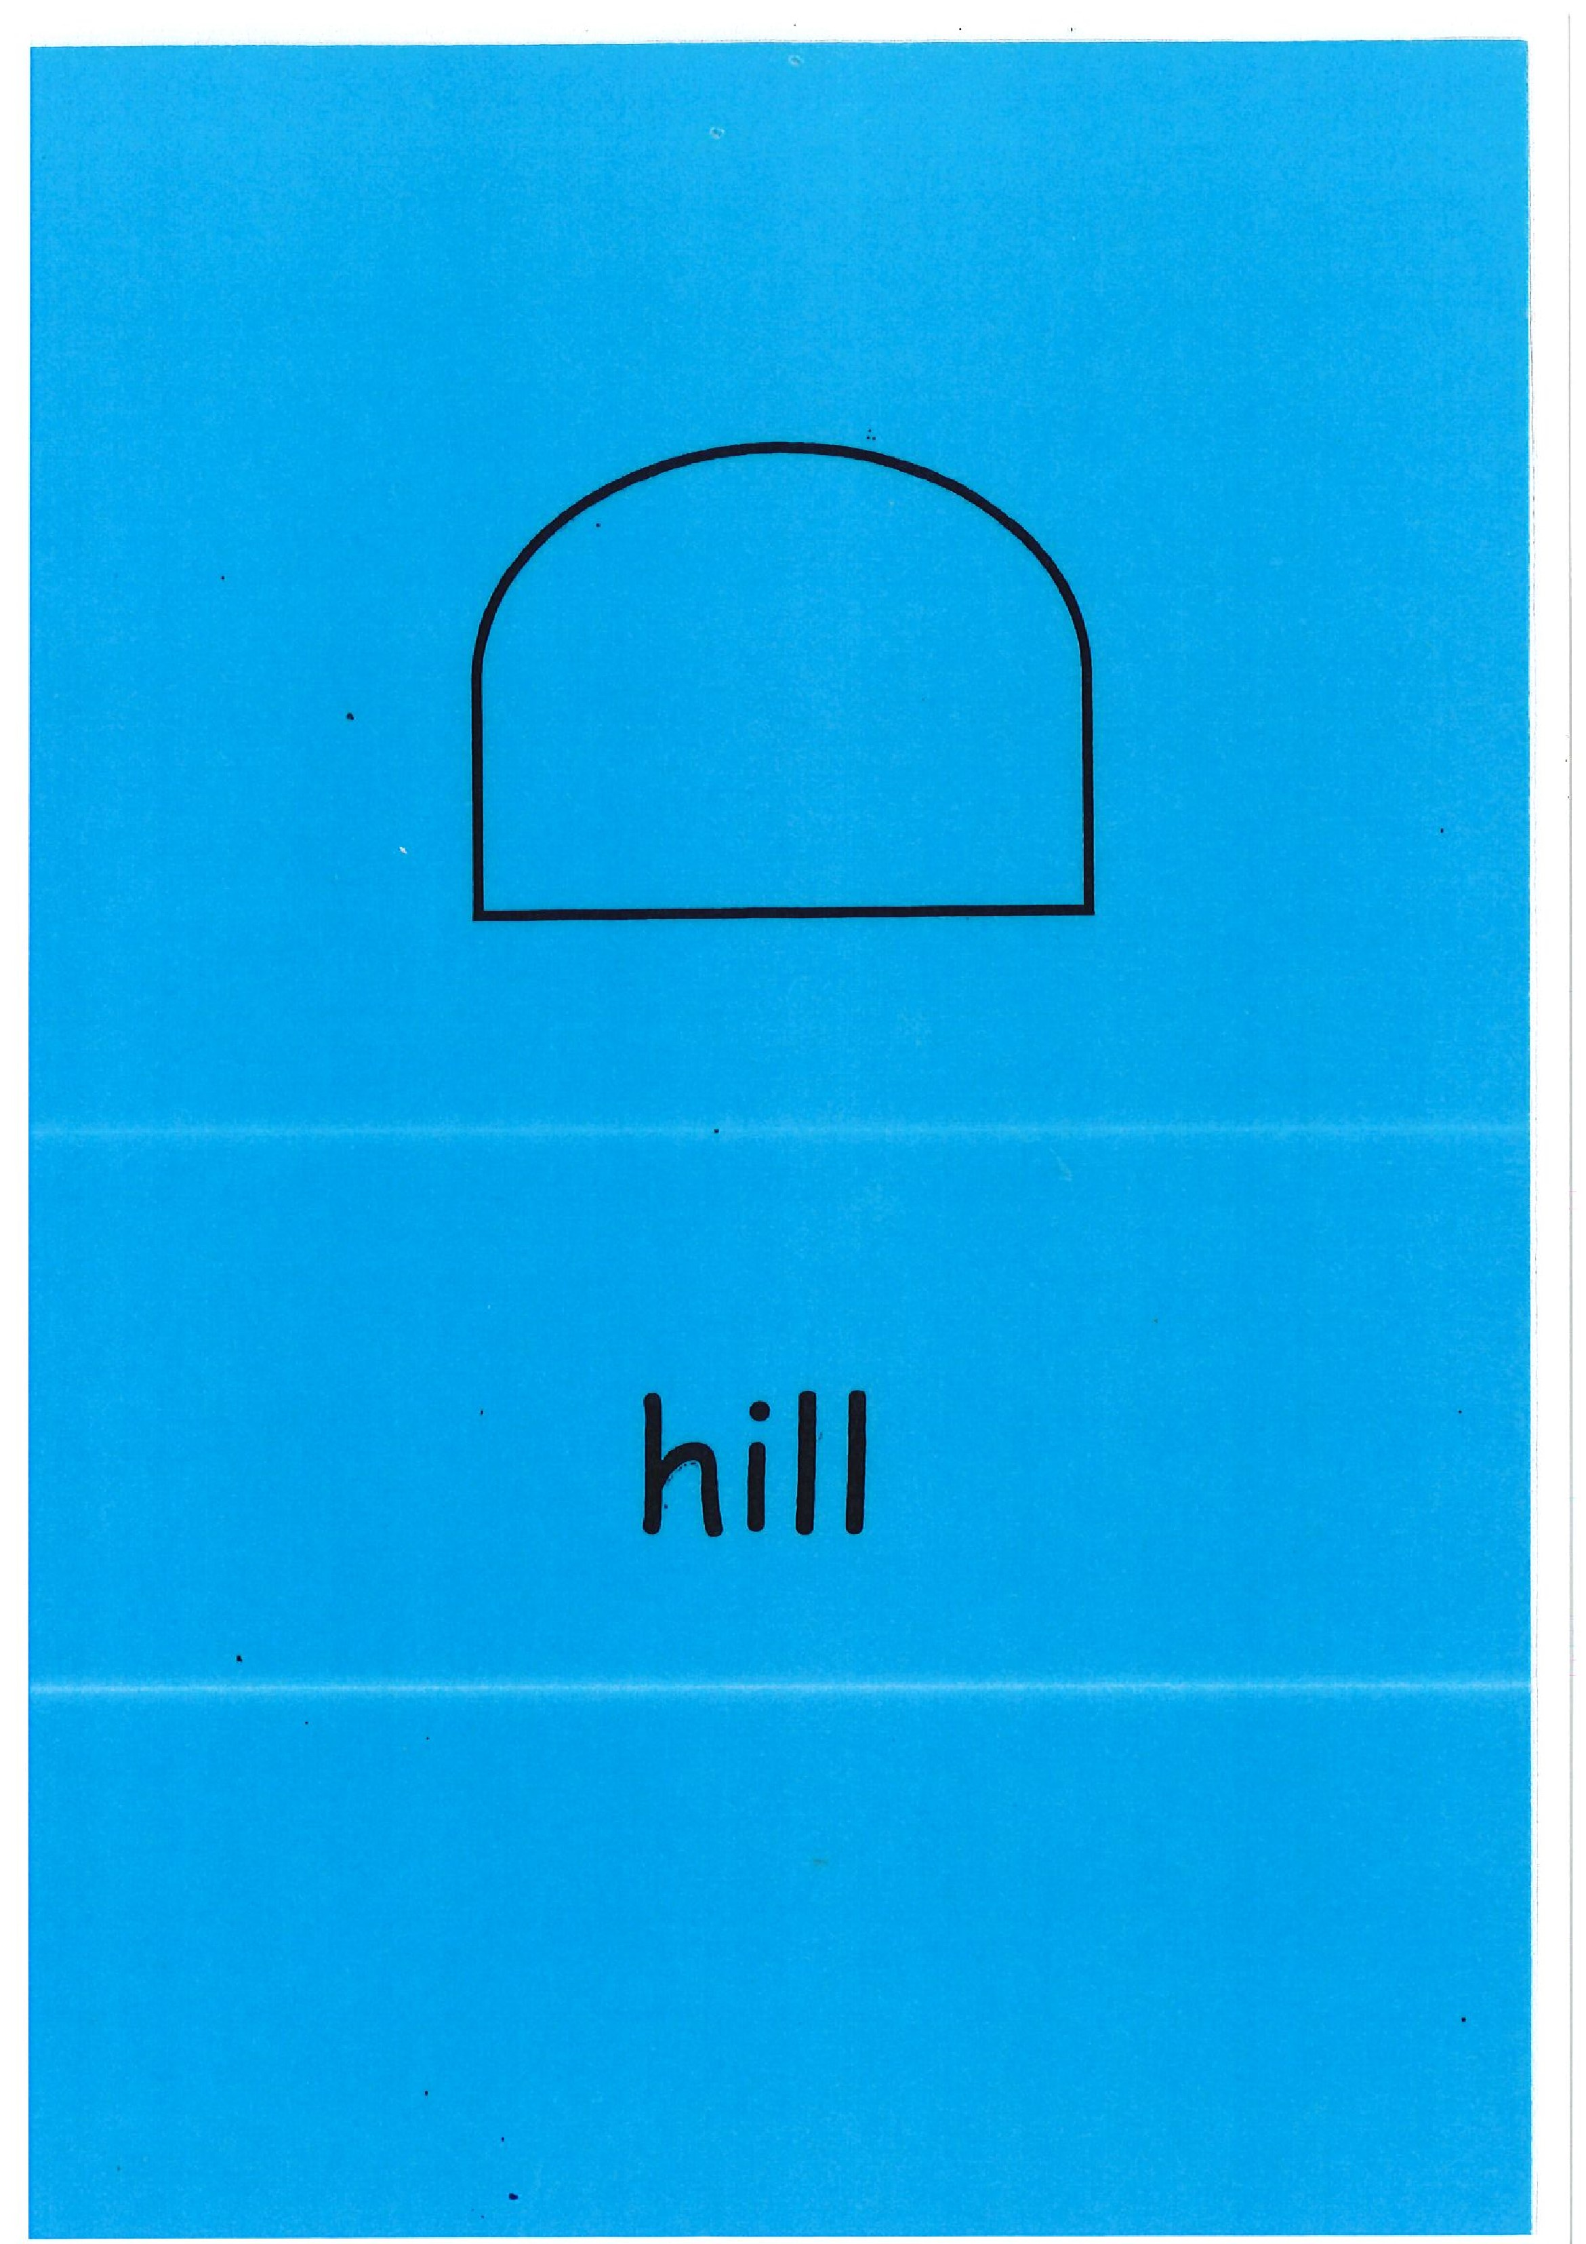

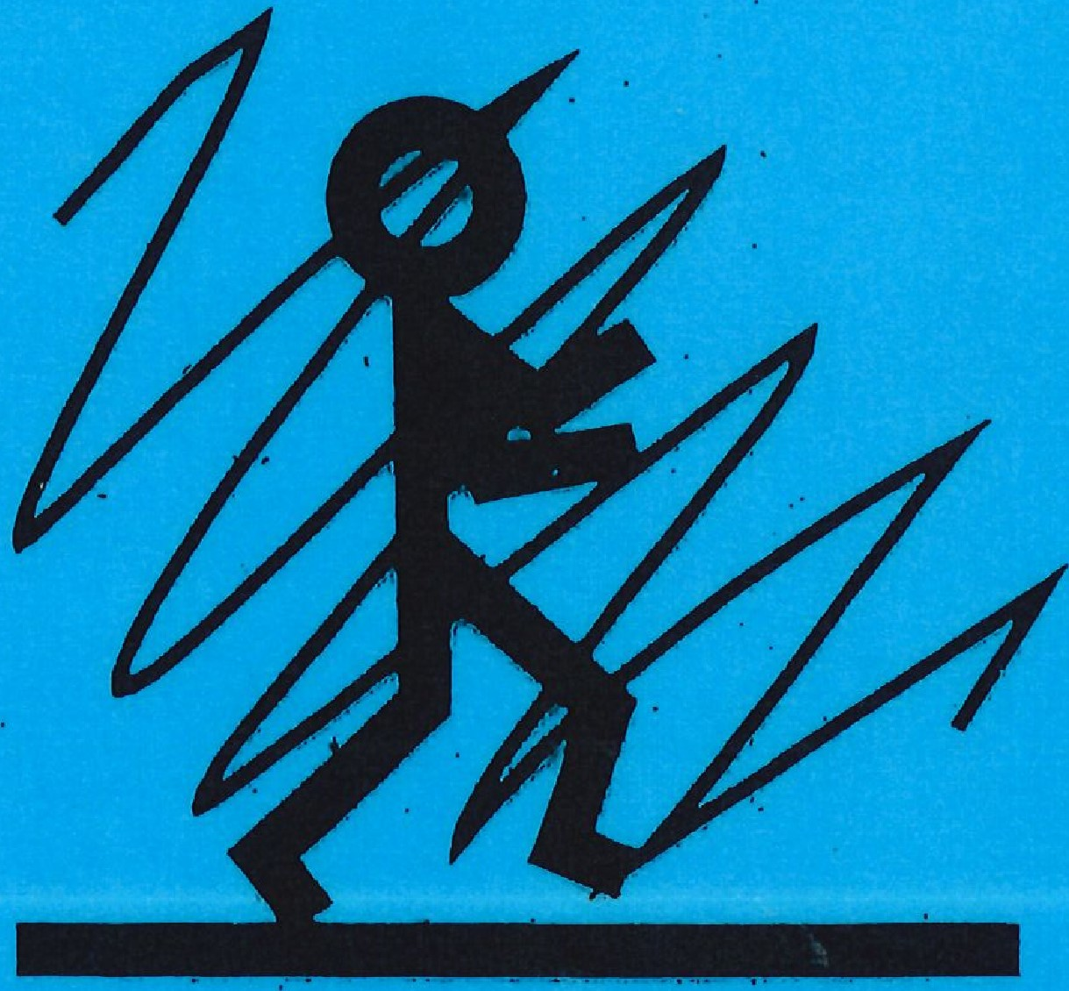
mist
paw prints
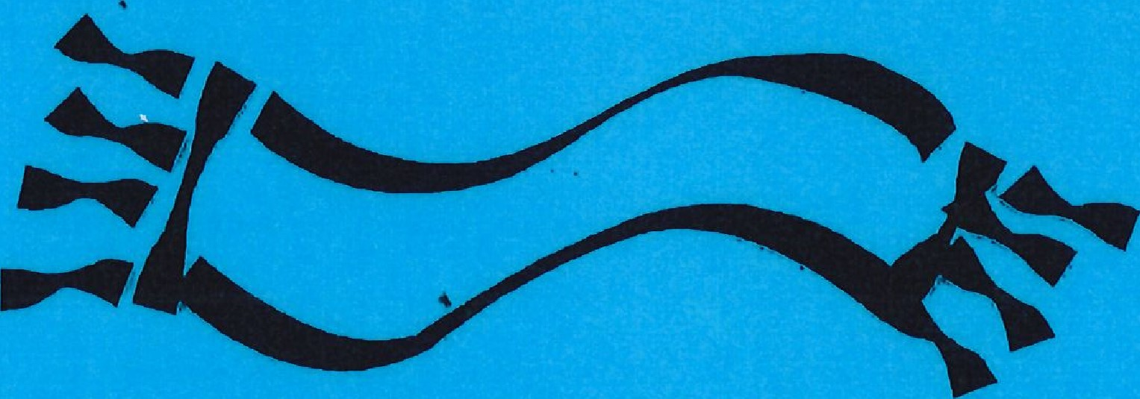
wrap up warm

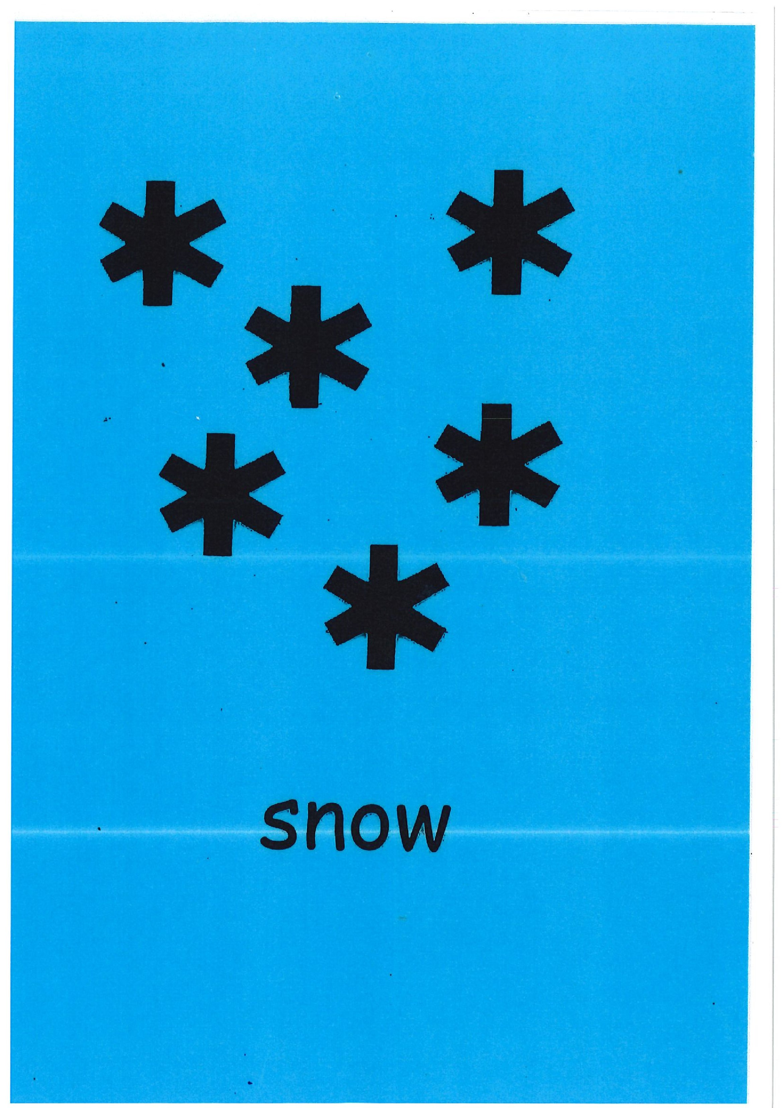

hail

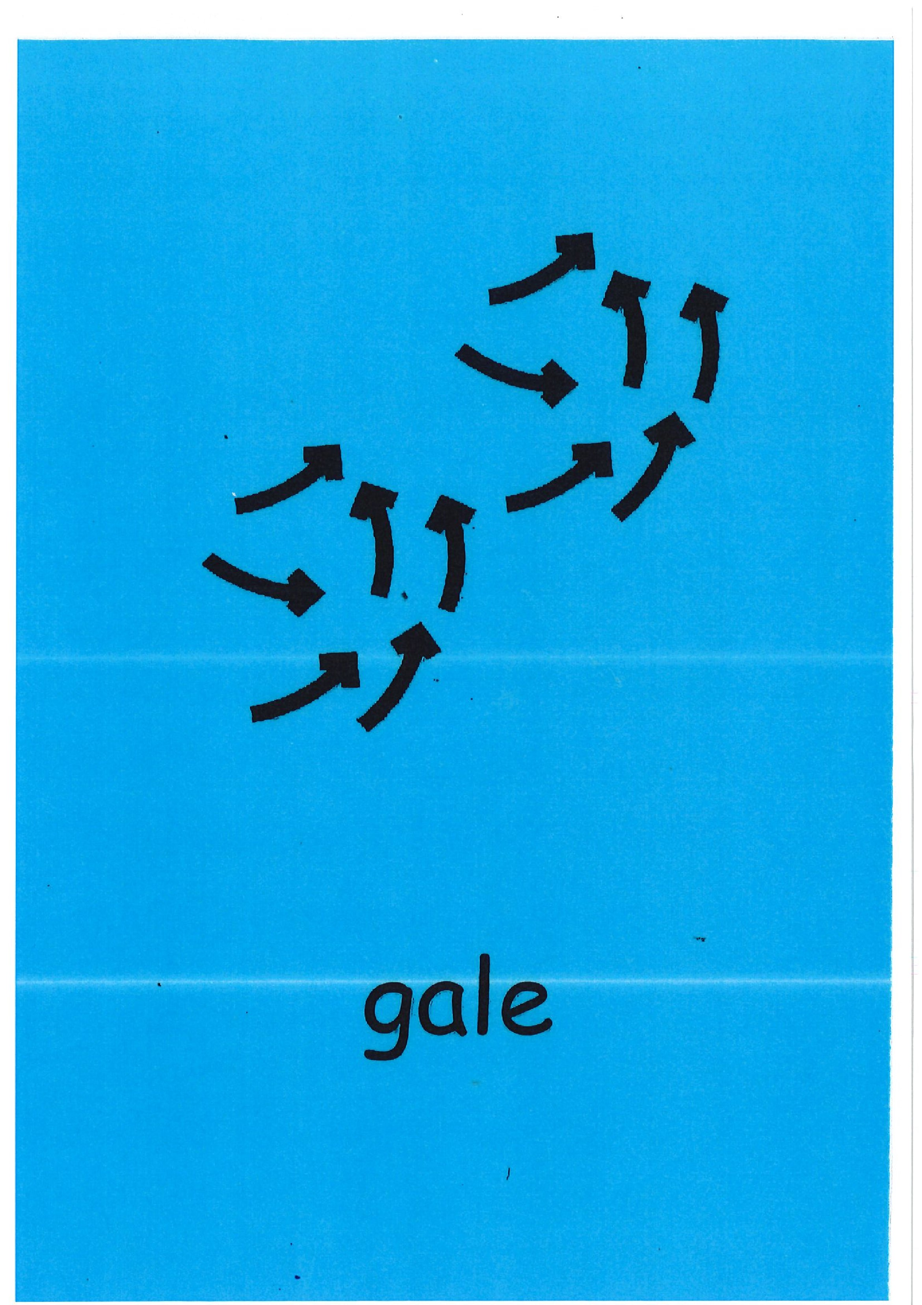

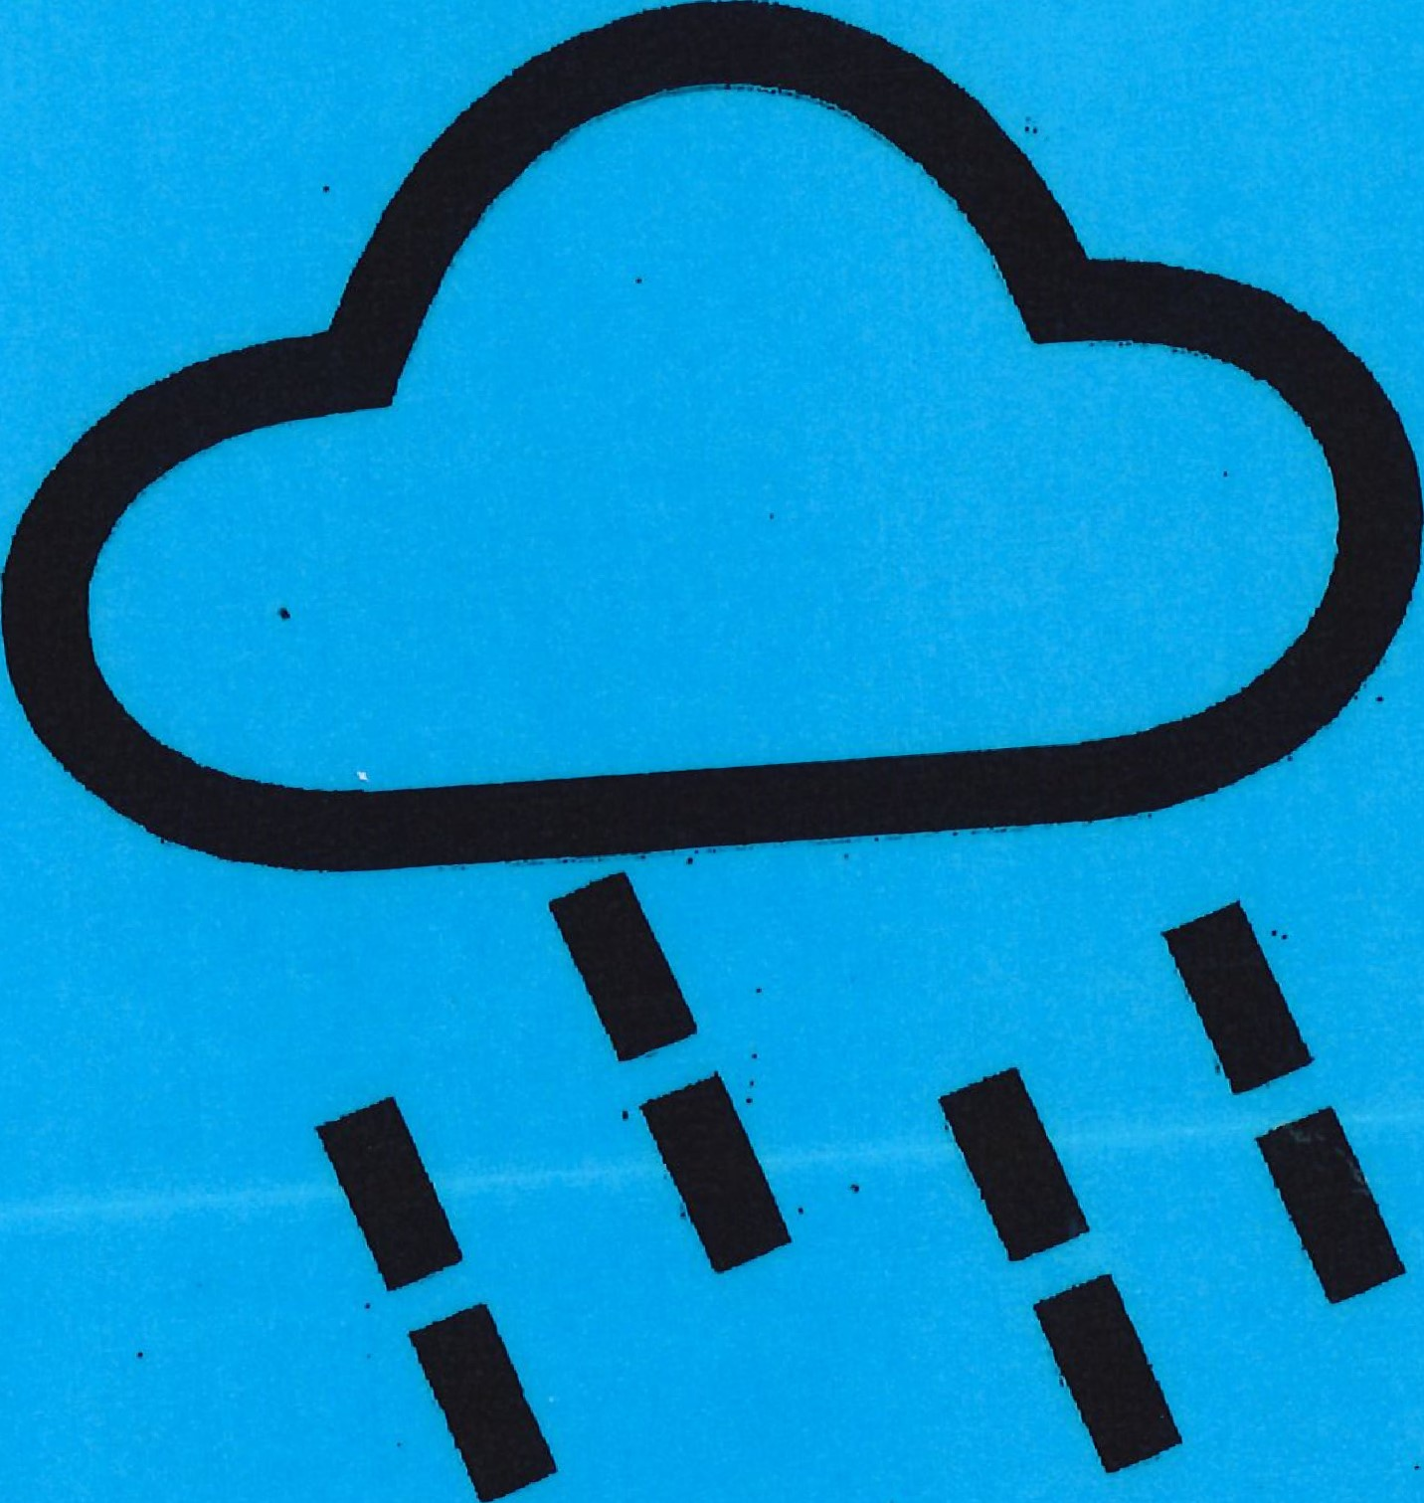
rain
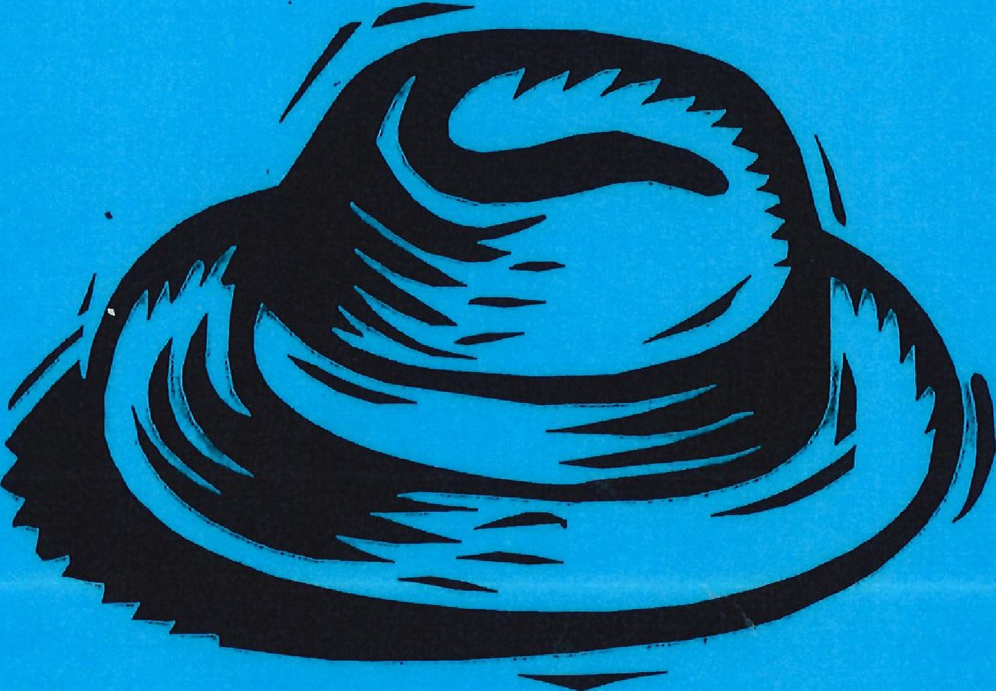
hat
wind
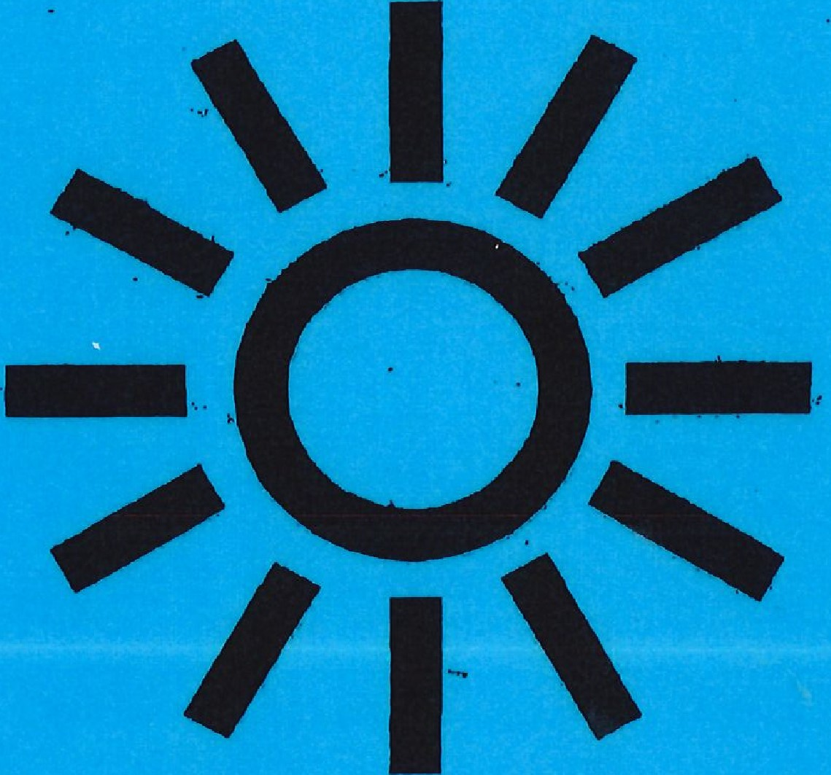
Sun
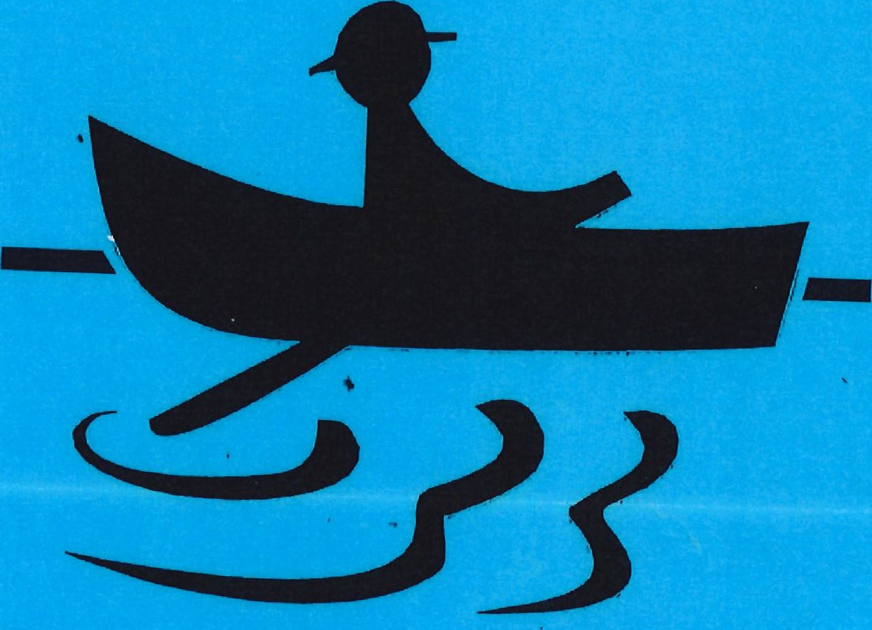
rowing boat
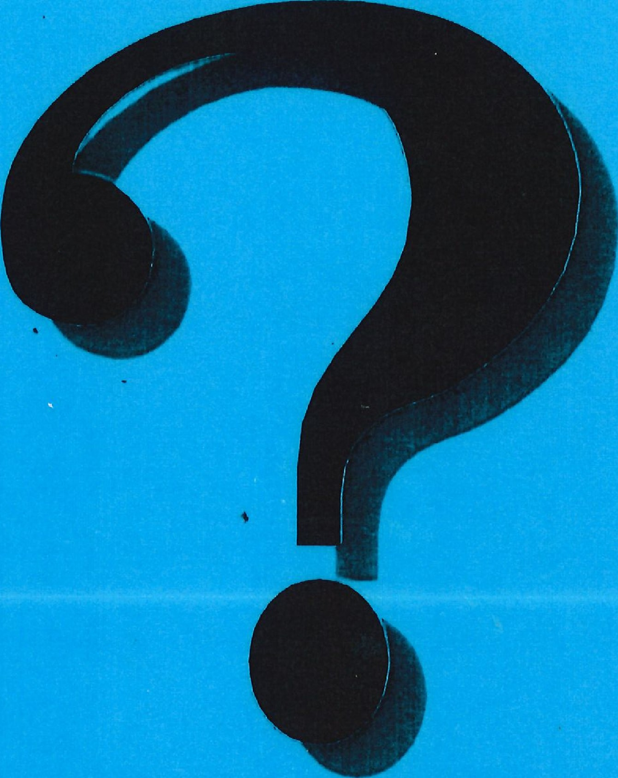
Ask permission
To the Island
By Karen Richards
A massage story about a journeyto an island in a rowing boat. Children gat into pairs and pretend to get into a rowing boat so that they are sitting one behind the other. Can I massage your back?
Today we're going to an Island — we're In our rowing boats.
(children sit one behind ttw other) set or In warm sun
(with one hand on the shoulder, take the other hand and make a circle clockwise on the back and
"sunrays" to the sides) But clouds gather
(make small circles with finger pads)
The wind walls
(Move hand from side to side)
Hold onto,your hats
(Stroke down from head to shoulders)
It's a sudden gate
(Move hand from side to side)
The rain begins to fall
(stroke down from shoulders with finger pads)
Drip, drlp, drip
(trace raindrops on the back)
Hail stones patter
("play*' 'tith finger tops on back) Tick, tick, tick
("play' with finger tops on back)
Oh! Nol Snowl
(press lightly with fingers slowly over back)
Let's wrap up warm
(stroke across shoutderv and down the arms)
This boat is going through a rpal storm
We've arrived at the Island and I can see Paw prints In the sand, what can It be?
("climb" up shoulder by first using palm of hand then "rolling" the hand upwards, first up one side, then the other side) A mist descends and all Is still
(bring hands down the back and by hands still)
U.p we climb, up the hill
(bring hands upvards in heart shapes the top of the back ) Where the sun shines through the sky so blue.
(begin at centrg of back and slowly make a circle, getting bigger and: bigger until the "sun" appears again.) Thank You

