Creating a Routine
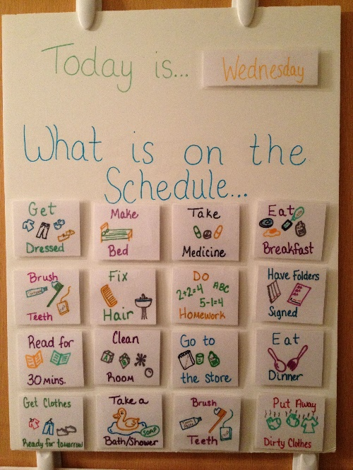
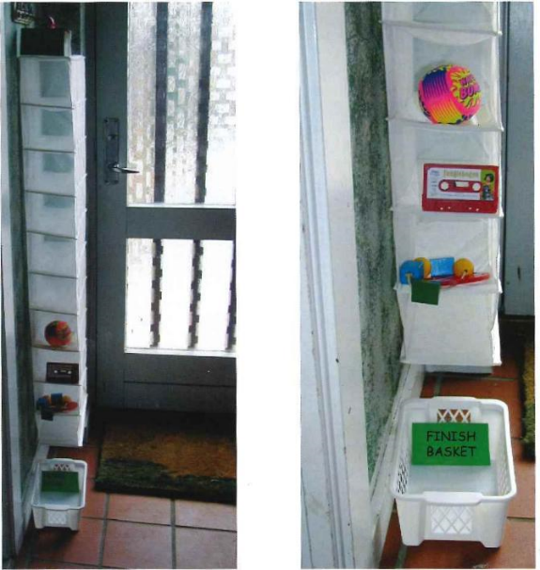
All children and young people with ASD need predictability and routine to feel safe and to know what is happening and what is going to happen next. This should always be communicated with visual supports so that it is permanent for your child. This means that they can go back and look at the plan whenever they need to. You do not have to use flashy symbols, you can draw your own, take photos or use objects – whatever makes most sense to your child. It can be on the fridge, on the wall or on an IPAD as long as they can see it.

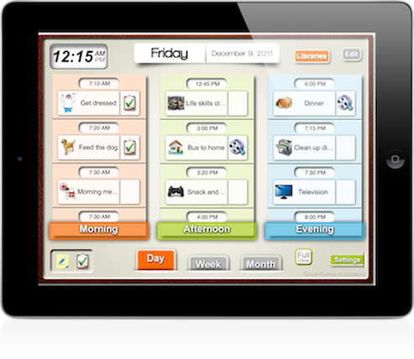

Think about the following:
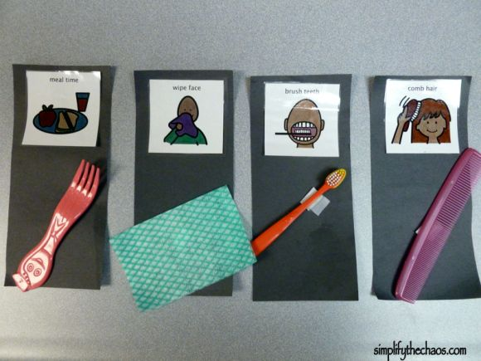
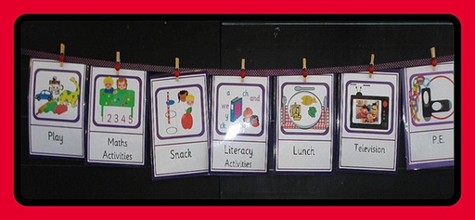
- Break the day down into sections, morning, afternoon and evening

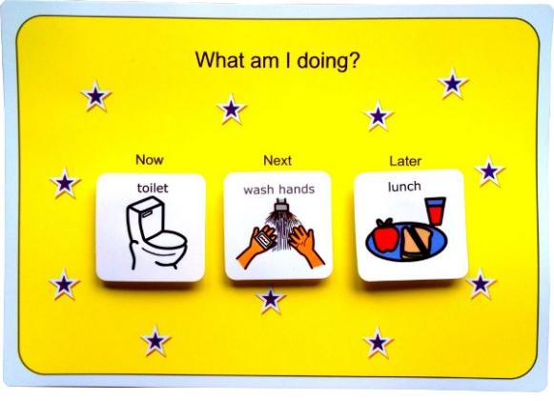
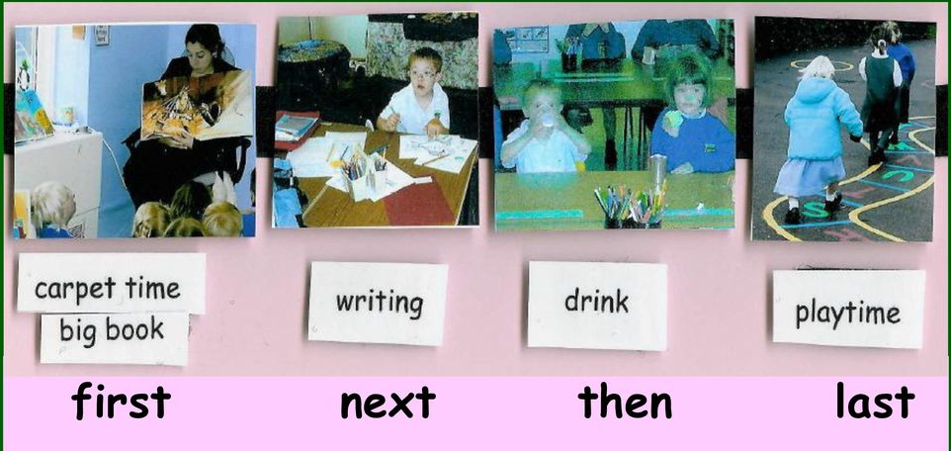
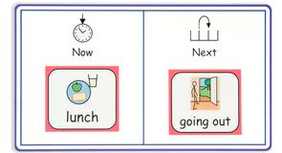
- Use a Now and Next or first /next/ later to simplify the plan
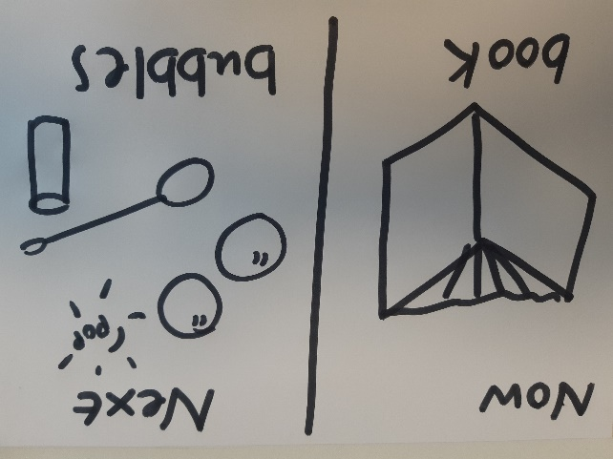

- You may need to have a directed activity such as a maths worksheet/game followed by a motivating activity they have chosen or you know that they enjoy
- Put family meal times in the plan
- Your child may need breaks/ sensory activities which will need to be on the plan
- Include family activities such as going to the park/playing in the garden, going on the trampoline or going for a walk with the dog in the plan
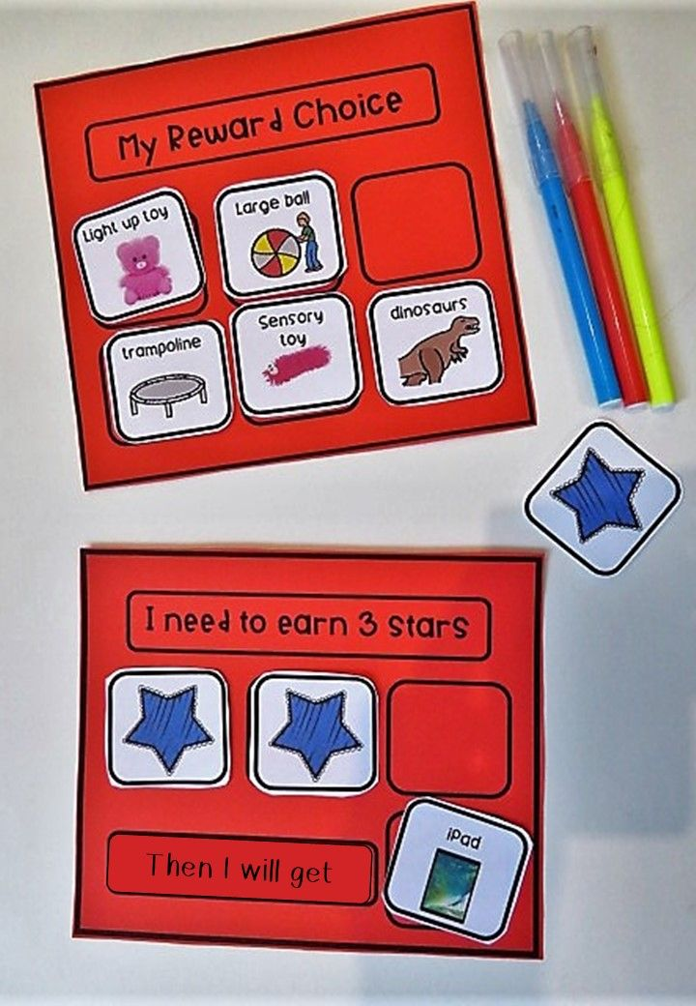
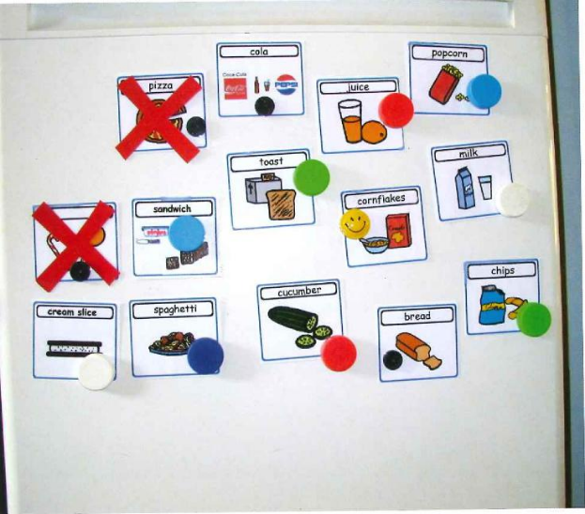
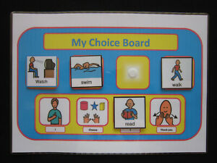
- Give choosing time on the plan so your child can choose from a range of options. Show them what they can have and perhaps what is not available. You could see if they will work for rewards.

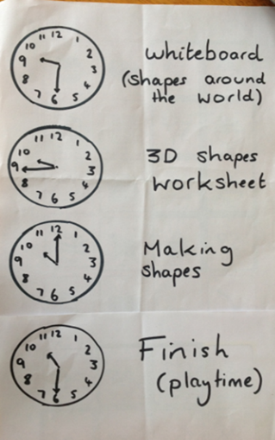
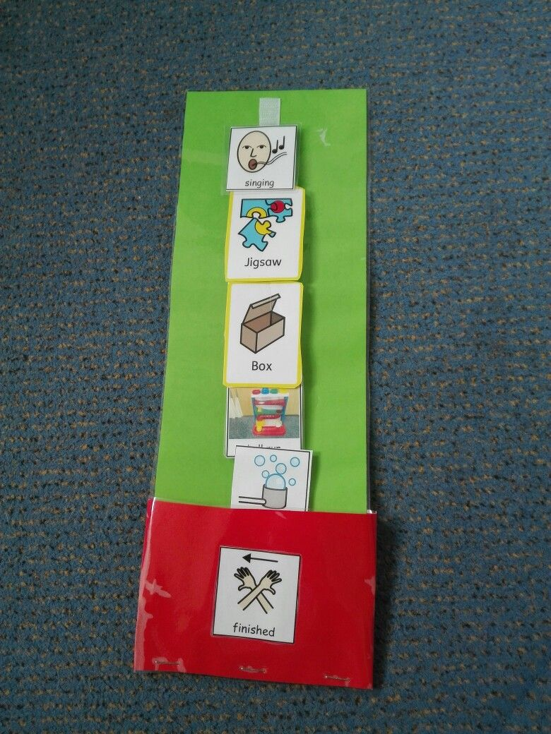
- When an activity is finished take it off the timetable or cross it out or remove symbol to show what they have finished.
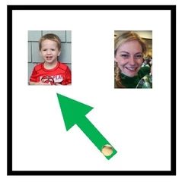
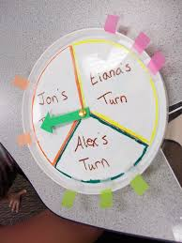
- You can also use a visual to shown turn taking in a game

