Maths Home learning activities

Pathway 2
Number:
- Choose a different number to explore every day (1-5) Count that many objects, make towers, draw or paint the numeral using different colours, look for it in the house.
- Talk about how many.
- Play pretend games, such as at the cafe, shop or on the bus count things together.
- Play games such as hopscotch and ‘What’s the time Mr Wolf?’
- Begin to introduce adding and taking away, such as building sandcastles and knocking them down.
- Sing counting songs and rhymes such as Ten Green Bottles and count it out on your fingers.
- Collect everyday items, like milk bottle tops, which your child can sort into colours or sizes and count.
- Play counting games like skittles or hopscotch
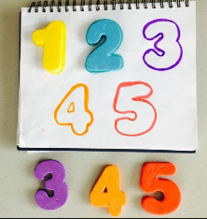
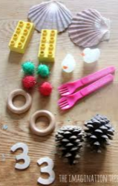
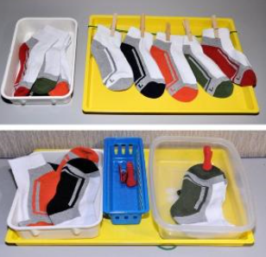

Shape:
- Choose a different 2D shape (square, circle, triangle, and rectangle) to explore every day. Look for the shape around the house and garden, draw the shape, make pictures, talk about how many sides and corners it has.
- Use junk, such as empty boxes and tubes to explore 3D shapes. Use large boxes that your child can get into.
Measures:
- Make an obstacle course with your child and use words such as under, over and through.
- Read stories, like Goldilocks and the three bears and talk about size such as big, bigger and biggest.
- Let your child help you at home when you’re using numbers, such as measuring ingredients for cooking
- Help your child sort coins by shape or size, big and little, on to plates or into bags, purses or jars.

