Taking my temperature

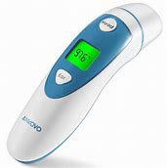

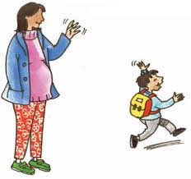

When I go to school/nursery the adults will take my tempture. They will place the thermometer on my head softly and wait a few seconds.

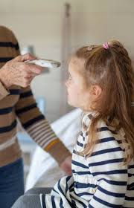

.

My teacher will let my Parents/career know if my temperature is up or if it is fine.

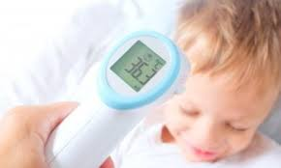

If my temperature is up my parents/career will take me home. I will stay at home until my parents know it is ok to go back to school. Adults know what to do keep me well and safe.

