Communication ideas for Home

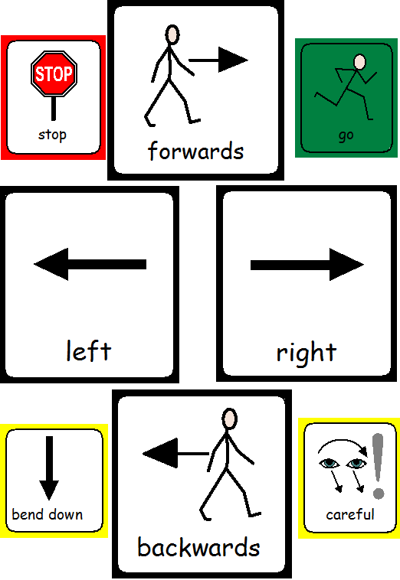
- Choose a word of the day and then describe that word together and think of how you would define it. Google it or look it up in the dictionary and see if your definition and descriptions match it.

- Watch a film or read a book then role play your favourite part together. Encourage your child to talk with emotion and expression and to use gestures alongside what they are saying.

- Role play going to the shop/ cinema etc and think about what you need to say to the people you meet.

- Blindfold yourself and get your child to direct you to particular place in your house using only words. You could then swap over and they have to listen to your instructions.

- Think about someone you would like to meet or see e.g. a famous person, friend or family member and think of 5 questions you would like to ask them.

- Model accurate grammar throughout your day as opportunities arise. For example if you child says ‘the mouses falled down ‘you could say ‘yes, the mice fell down’.

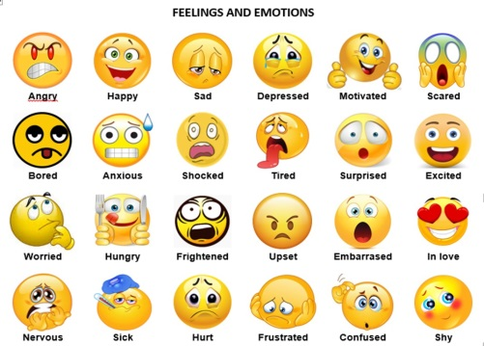
- Have a question of the day that develops your child’s verbal reasoning, this could be a why question, how do you know? Or what would happen if? Ask your target question as you do your daily activities e.g. Why do we brush our teeth? How do you know lunch is ready? etc

- Label your child’s emotions throughout the day; try to extend the vocabulary by using emotions such as excited, jealous, guilty, embarrassed or content. Or while watching a film see if you can spot how the character feels using an advanced emotion word.

- Model additional describing words throughout the day for example if your child says, ‘that elephant is really big’ you could say ‘yes, it’s huge or enormous’. Or if your child says ‘that cake is yummy’ you could say ‘yes, it’s delicious’. See if your child can think of their own alternative describing words.

- Choose a social skill to focus on each day and draw a picture of it or write it down and put it on the fridge to remind everyone in the house what you are practising, this could be, taking turns and not interrupting, looking at the person you are talking to, staying on topic or asking questions to keep a conversation going.

- Choose an idiom of the day e.g. having a whale of a time, it’s a piece of cake, give me a hand etc. Think about what is really means together and see if you can use it appropriately throughout the day.
Make these sentences more exciting by adding describing words:

The _______ girl ate the _______ cake.

The _______ car was driving on the _______ road.

The _______ fish was swimming in the ________ fish tank.

The _______ pig was eating a ________ apple.

The ________ man was watching a ________ film.

The _________ puppy was jumping over the __________ fence.

The ________ house was sold to the _______ man.

The __________ monkey was eating a ________ banana.

The ___________ snake was sliding on the ____________ ground.

The ________ boy was drinking a _______ drink.

Common idioms

1. Below on the left are some common idioms. Choose the correct meaning from the list on the right.

1. give the game away a) make people feel relaxed with each other 2. give and take b) know everything about a subject
3. have it in for someone c) find compromises
4. know it inside out d) be determined to hurt or criticize
5. break the ice e) spoil a secret surprise or joke

2. The following idioms are missing prepositions. Can you guess which preposition goes where?
(Using - on out on for out out of over under)

1. He didn’t get any authority to take the action. He went ................. his boss’s head.
2. Don’t say a word to anyone, do you promise? Keep it ................. your hat.
3. Go easy ................. her. She doesn’t understand. She’s only a child.
4. She won’t tell me anything. It’s like trying to get blood ................. a stone.
5. Go on spoil yourselves. Push the boat ................. for a change.
6. She’s got a good ear ................. languages and she’s pretty musical as well.
7. That was quick. You’re ................. the ball this morning.
8. I’ve had it ................. with him and we seem to have resolved most of the problems.

3. Match the beginnings and ends of these idioms.

1. a last ditch a like a headless chicken
2. way b the drain
3. make a clean break c a hasty retreat
4. go down d into your pockets
5. running around e out of line
6. dig deep f clean slate
7. beat g with the past

Choose 4 of these idioms and think of an appropriate context you might use them in.

4. Comparisons: As + adj + as noun
Match the two halves of the idioms
1. as blind a as a cucumber
2. as clear b as mud
3. as cool c as a feather
4. as quick d as a bat
5. as light e as a flash

Comments, Questions and Staying on Topic:
Which one is which?

I like the colour red.

- Do you like the colour orange as well?
- I like red too.
- I want to go to the beach.

My friend lives in America.

- I would love to go to America.
- Have you visited him?
- Will you go to France on the school trip?

My puppy ate my mum’s slipper last night.

- What is your puppy’s name?
- That’s pretty funny.
- Do you like going fishing?

I think I bed to go to bed early tonight.

- I have a new book.
- Me too!
- Are you tired?

I would like a chocolate bar.

- I am going to Spain tomorrow.
- What chocolate bar do you want?
- That’s a great idea!

Auditory Memory ideas

Auditory memory is the memory for things you have just heard. It is an important skill as it helps you keep words long enough in your head for you to be able to work out what they mean. It is easier to remember what you have heard if you can see things which remind you. Before you try these activities, make sure that your child:

- Will not be distracted by noises or other things going on nearby
- Is ready to listen (i.e. call his/her name)
- Keeps looking at you while you are talking
- Waits for you to finish before starting

If your child gets part but not all of it right, try again with the whole sentence. Breaking the sentence down makes it a lot easier, so only do this after a couple of tries – it is good for your child to experience success in the end! Try not to give away clues with your hands or through looking at the right things.

Activities

- Spread some objects/ pictures visibly around the room. Then take it in turns to tell the other which ones to collect. Give a moment for the person to see where they are, then say ‘ready-steady-go’. See who can collect their pictures/ objects the fastest. Start off with having 3 at a time and increase it if it’s too easy.

- Put some objects (or pictures) under up-turned beakers/boxes (one under each). Mix the beakers around and then take it in turns to say which 3 the other person has to hunt for under the cups. Again, if 3 is too easy, increase the number you say at a time to the appropriate level for your child.
- A ’sorting out’ game, telling each other where to put the objects. E.g. ‘put the ball in the box and the cup and car in the bag!’ This is a 5-word example. Choose an easier sentence depending on what your child can cope with.

- When you have read a story, get your child to re-tell it without looking at the pictures again. Try to go through everything that happened in it – you might need to give some clues/ alternatives if your child gets stuck.

- ‘I went shopping and I bought…’ game. Take turns to add an item to the list. Each time you must repeat all the items in the list in the right order. Encourage the child to look at the person to help them remember what that person bought.

- ‘Name that tune’ Hum or sing a tune e.g. ‘Eastenders’, ‘Blue Peter’, a song from school. Can the children say where it is from?

- ‘The Lorry Driver’ draw a simple map on a piece of paper with some roads, a school, shop, car park, library etc. on it. Name the streets. Give instructions to follow e.g. ‘Go up Silly Street and turn left at the top and drive past the swimming baths’.

