Having a test for Coronavirus

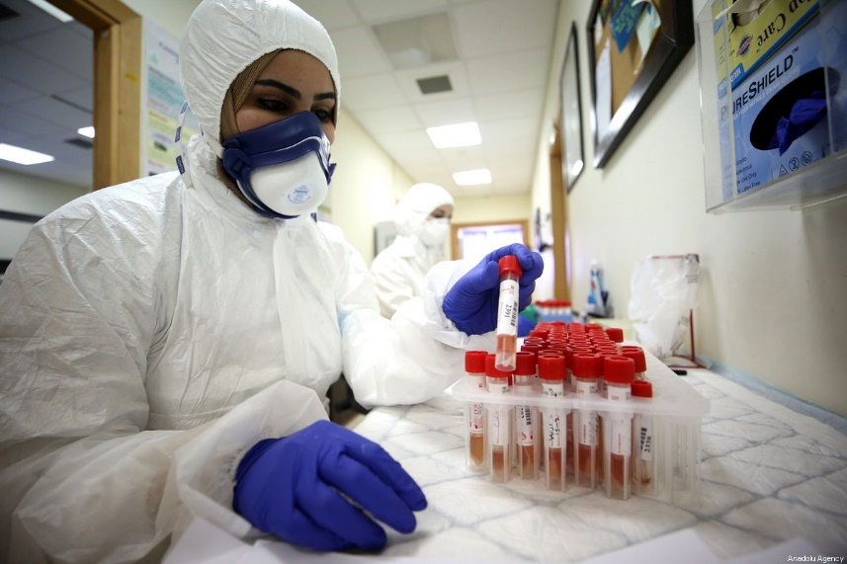

When children and adults feel unwell with either a cough, high temperature or have changes in their smell and taste they may need a test for Coronavirus. The doctor will let the adults know if you need a test.

If you need a test, you may have to go to a drive in test centre a bit like a Mc Donald’s. If you have to go to a test centre the adults will be wearing a mask, a visor and a protective apron and gloves. This is to protect them and you from the virus.
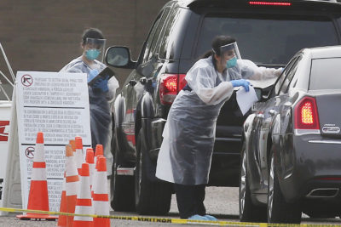

Or the doctor may send the test home for the adults to do in your house.

The adult doing the test will put a cotton bud up your nose and move it around. Sometimes they may have to use another cotton bud to rub the inside of your mouth as well. The cotton buds are then sent to the hospital for testing.

Your adults will get a phone call or an email with the results after 3 to 4 days. While you are waiting to see if you have the virus you will stay at home. Your adults will know what to do to keep you safe and well.
