Maths Home learning activities

Pathway 3
Number:
- Choose a different number to explore every day (1-10 and then above) Count that many objects, make towers, draw or paint the numeral using different colours, look for it in the house. How many different ways can you make the number by adding 2 numbers?
- Collect everyday items, like milk bottle tops, which your child can sort into colours or sizes and count.
- Talk about lots, one more or less and how many.
- Play games that involve moving counters backwards and forwards while counting, such as snakes and ladders.
- Play card games where you have to match things, like snap.
- Play games such as skittles, where you keep score and count how many are knocked down.
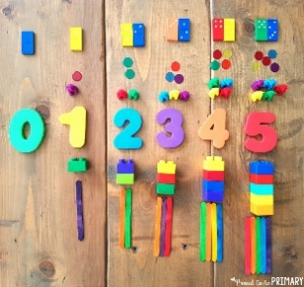
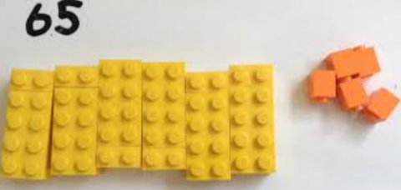
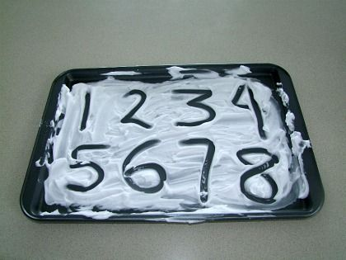
- Use estimates in everyday activities, such as asking “How many cakes will we need if Granny and Grandad come to tea?”

Shape:
- Go on a shape hunt and point out all the shapes you see, such as square windows or round wheels
- Choose a different 2D shape (hexagon, pentagon, oval, heart, star) to explore every day. Look for the shape around the house and garden, draw the shape, make pictures, talk about how many sides and corners it has.
- Explore 3D shapes around the house. Which are good for building with, which are good for rolling?
- Use junk, such as empty boxes and tubes to explore 3D shapes. Use large boxes that your child can get into.
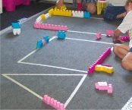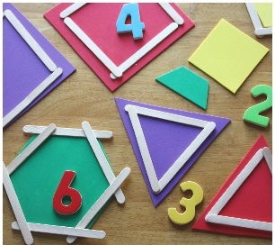

Measures:
- Let your child help you at home when you’re using measures, such as measuring ingredients for cooking or measuring for DIY.
- Give your child objects that are different weights to throw. Talk about how heavy or light they are, and how far or high they can throw them.
- Use a wheelbarrow or bag to move objects. Talk to your child about things being lighter or heavier than each other.
- Talk about time, such as “How long does it take to wash your hands?”
- Hide objects and use clues to help your child to find them, such as “It’s on top of the table, next to the remote control”.
- Help your child sort coins by shape or size, big and little, on to plates or into bags, purses or jars
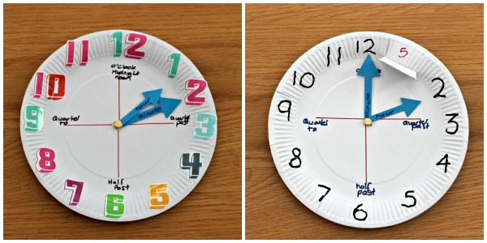

Problem Solving:
- Making something in cooking and using the terminology “more than, less than, bigger , smaller , how much, how many , total up to 10”
- Using appropriate coins to buy snack items in pretend shop.
- Shopping problems such as finding the correct amounts and change required for items priced up to 10p
- Keep a healthy eating diary recording when your child eats a certain type of food e.g. apple, banana, pasta and rice.
- To use comparative language when discussing the findings of their healthy eating diary above e.g. “I had apples nearly every day so the block graph for apples will be the tallest, the least amount of food I ate was rice so this block graph will be the smallest”.
