Occupational Therapy Activities
The NHS Greater Glasgow and Clyde website has some fantastic ideas for parents to try at home with their children. Click on this link:
https://www.nhsggc.org.uk/kids/resources/

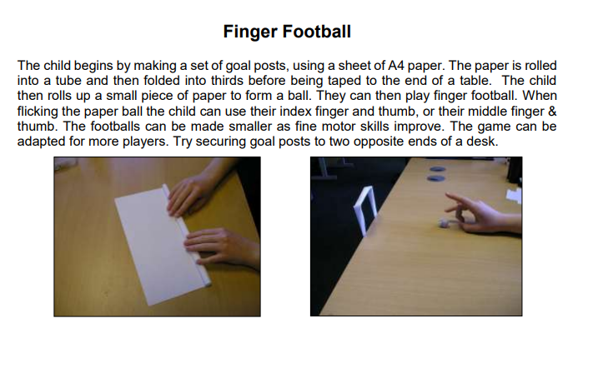
Activities are organised into the following categories:
- Activities of Daily Living
- Self-care
- Play and Leisure
- Education
- Fine Motor
- Gross Motor
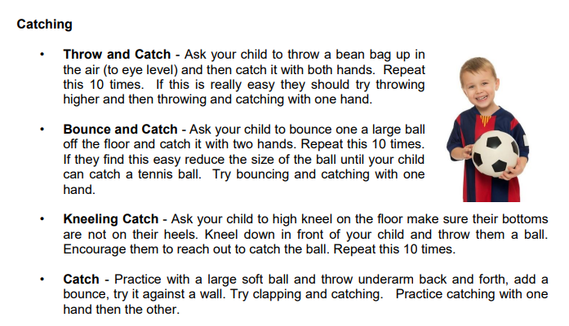
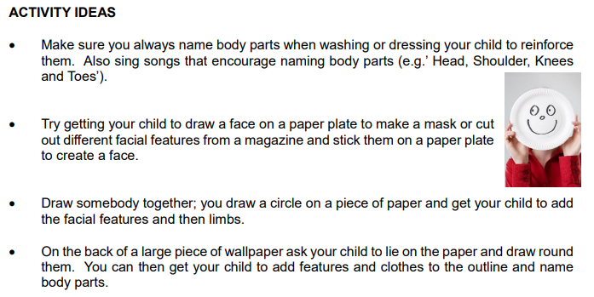
- Sensory

