Important things you should know about me:
Things you can do to help me:

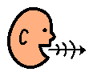
Hi I’m

How I communicate:

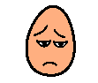


Things I like:
*

Things I don’t like:
*

