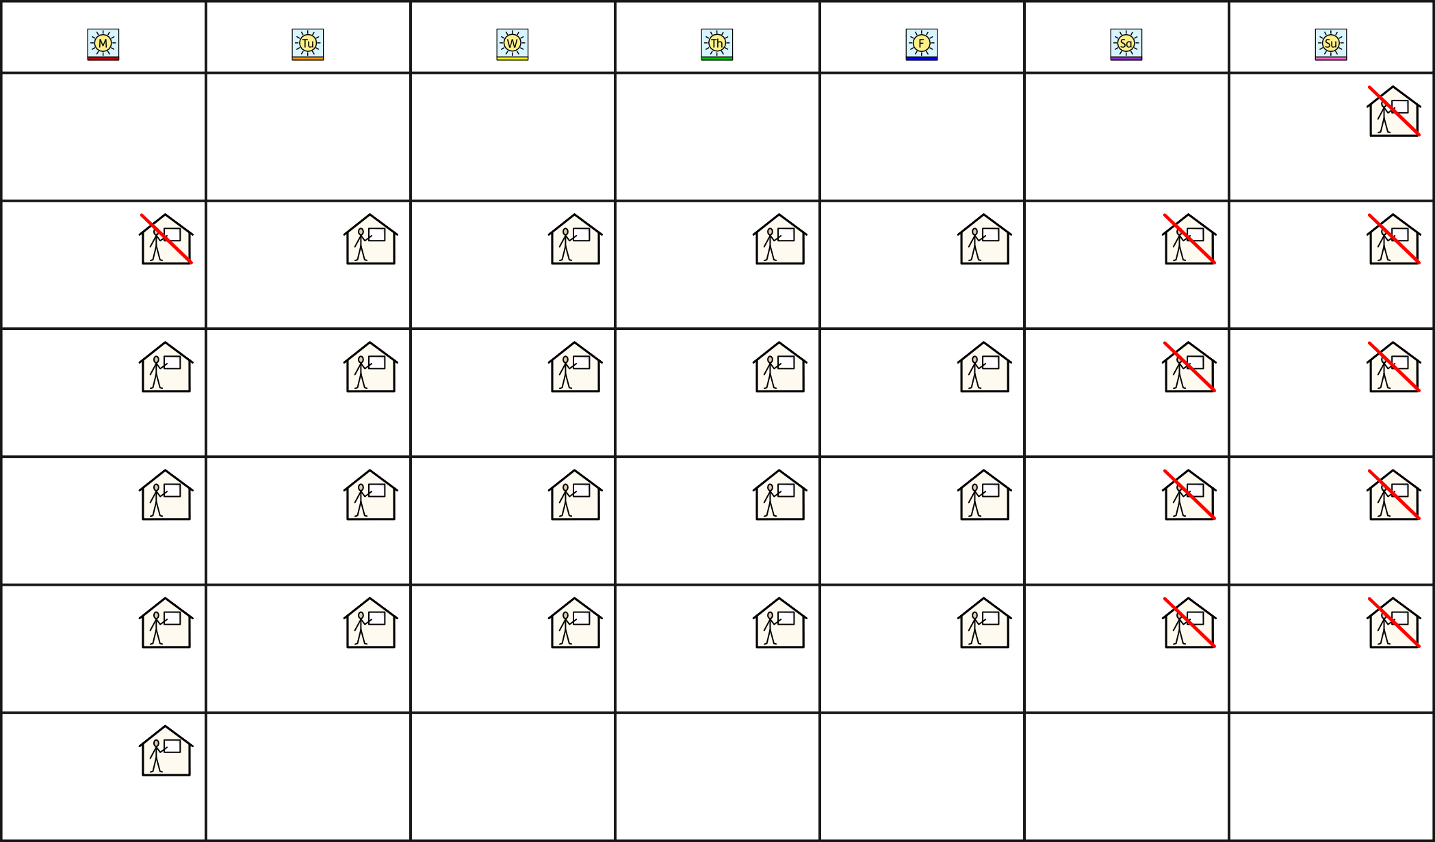September 2024

Monday Tuesday Wednesday Thursday Friday Saturday Sunday

1

2 3 4 5 6 7 8

9 10 11 12 13 14 15

16 17 18 19 20 21 22

23 24 25 26 27 28 29

30

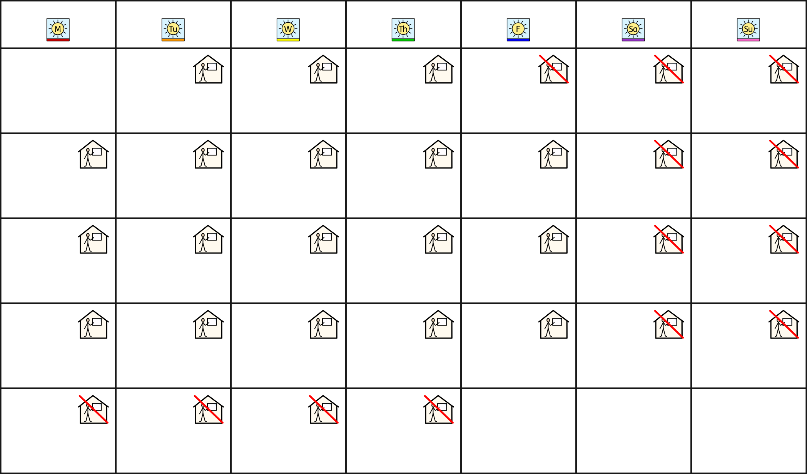October 2024

Monday Tuesday Wednesday Thursday Friday Saturday Sunday

1 2 3 4 5 6

7 8 9 10 11 12 13

14 15 16 17 18 19 20

21 22 23 24 25 26 27

28 29 30 31

November



# 2024

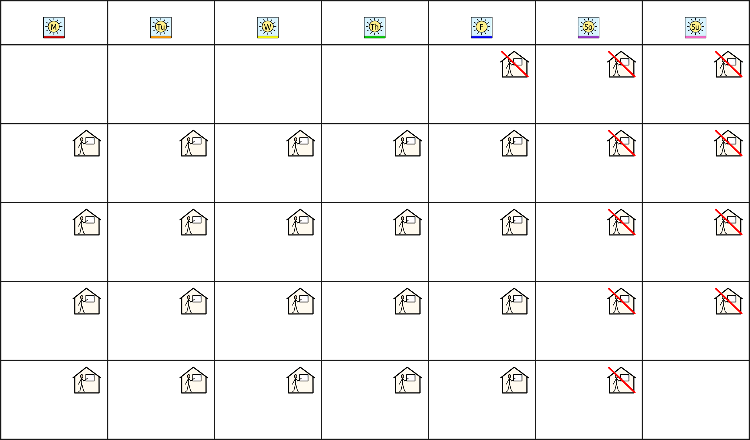

Monday Tuesday Wednesday Thursday Friday Saturday Sunday

1 2 3

4 5 6 7 8 9 10

11 12 13 14 15 16 17

18 19 20 21 22 23 24

25 26 27 28 29 30

December



# 2024

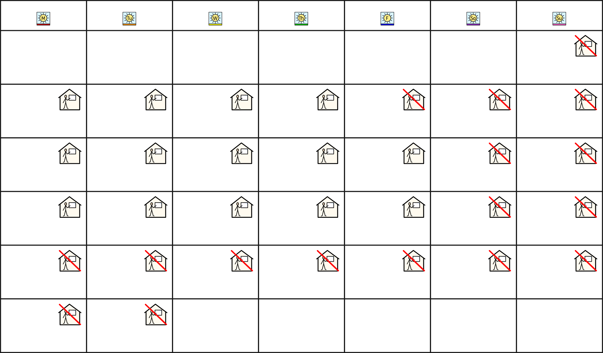

Monday Tuesday Wednesday Thursday Friday Saturday Sunday

1

2 3 4 5 6 7 8

9 10 11 12 13 14 15

16 17 18 19 20 21 22

23 24 25 26 27 28 29

30 31

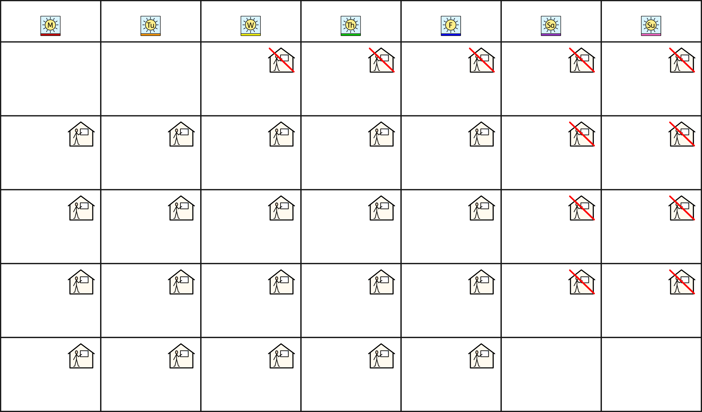January 2025

Monday Tuesday Wednesday Thursday Friday Saturday Sunday

1 2 3 4 5

6 7 8 9 10 11 12

13 14 15 16 17 18 19

20 21 22 23 24 25 26

27 28 29 30 31

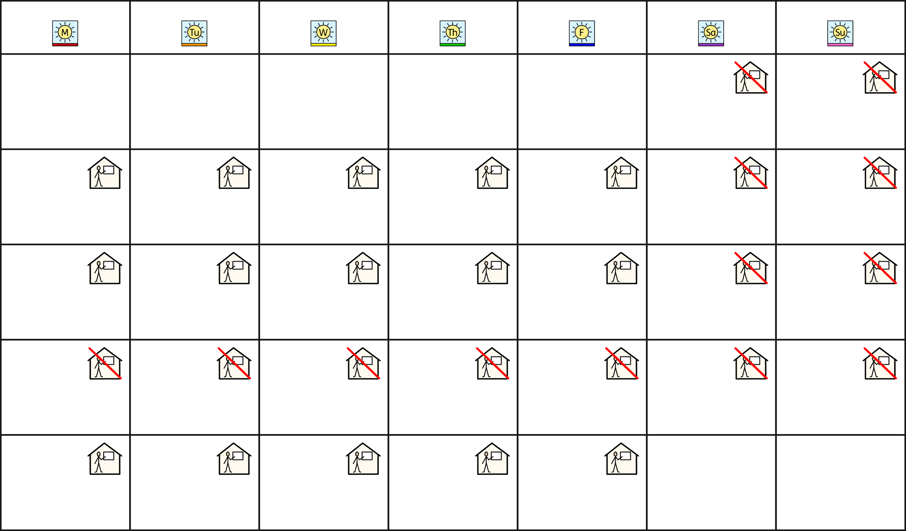February 2025

Monday Tuesday Wednesday Thursday Friday Saturday Sunday

1 2

3 4 5 6 7 8 9

10 11 12 13 14 15 16

17 18 19 20 21 22 23

24 25 26 27 28

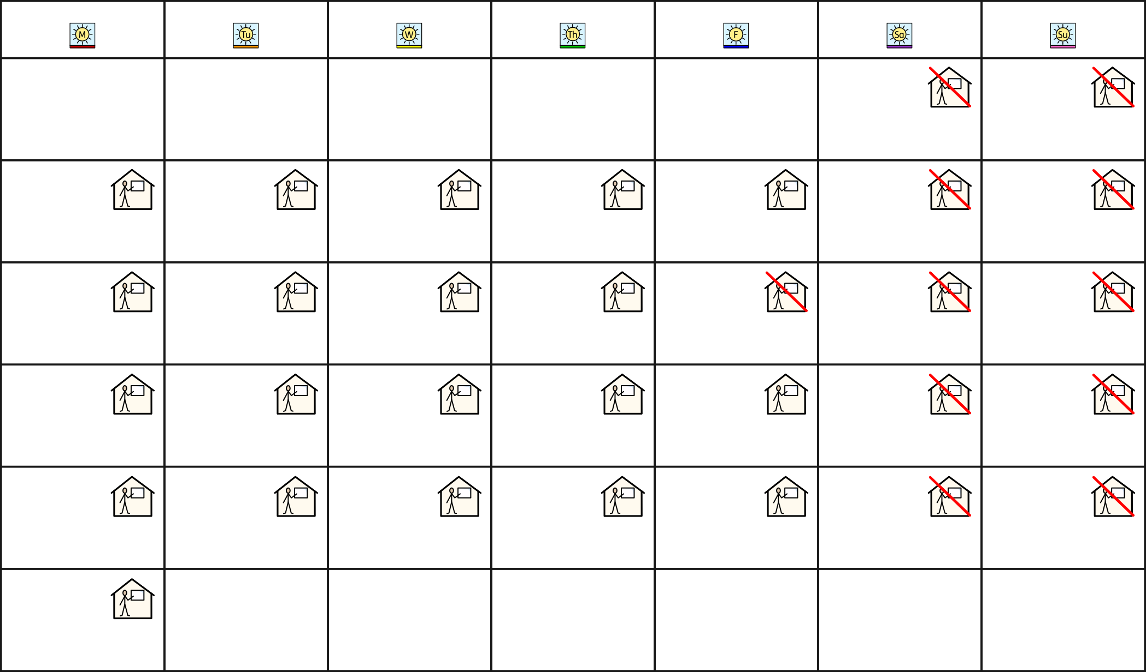March 2025

|  |  |  |  |  |  |  |  |  |  |  |  |  |
| --- | --- | --- | --- | --- | --- | --- | --- | --- | --- | --- | --- | --- |
|  | Monday |  | Tuesday | Wednesday |  | Thursday |  | Friday |  | Saturday |  | Sunday |
|  |  |  |  |  |  |  |  | 1 |  | 2 |  |
| 3 |  | 4 |  | 5 | 6 |  | 7 |  | 8 |  | 9 |  |
| 10 |  | 11 |  | 12 | 13 |  | 14 |  | 15 |  | 16 |  |
| 17 |  | 18 |  | 19 | 20 |  | 21 |  | 22 |  | 23 |  |
| 24 |  | 25 |  | 26 | 27 |  | 28 |  | 29 |  | 30 |  |

31

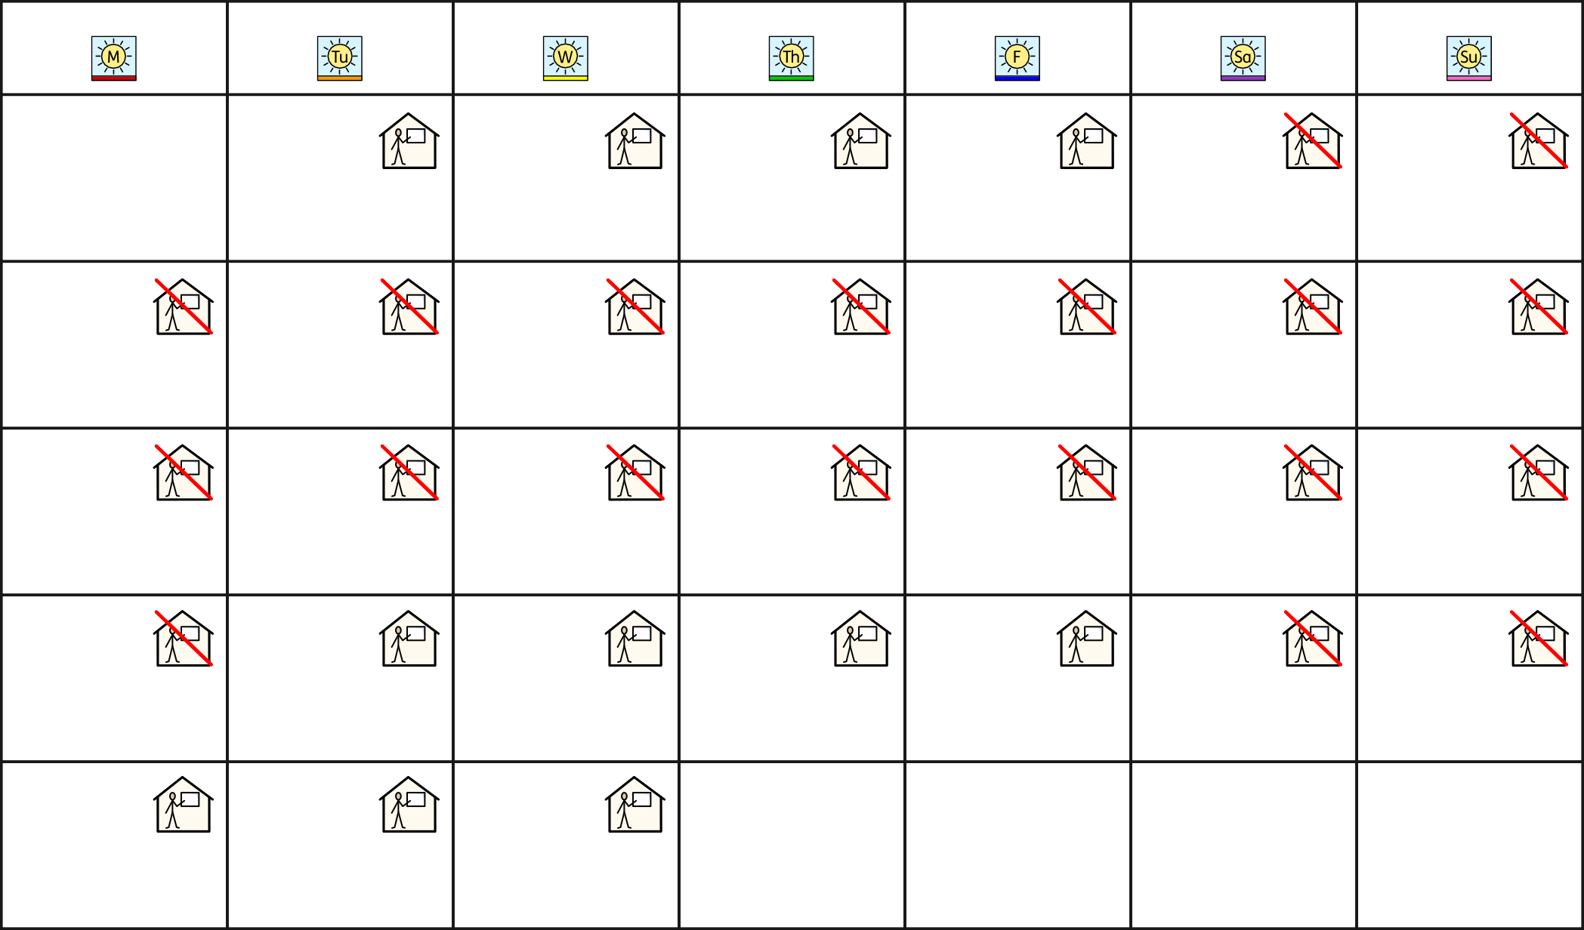April 2025

Monday Tuesday Wednesday Thursday Friday Saturday Sunday

1 2 3 4 5 6

7 8 9 10 11 12 13

14 15 16 17 18 19 20

21 22 23 24 25 26 27

28 29 30

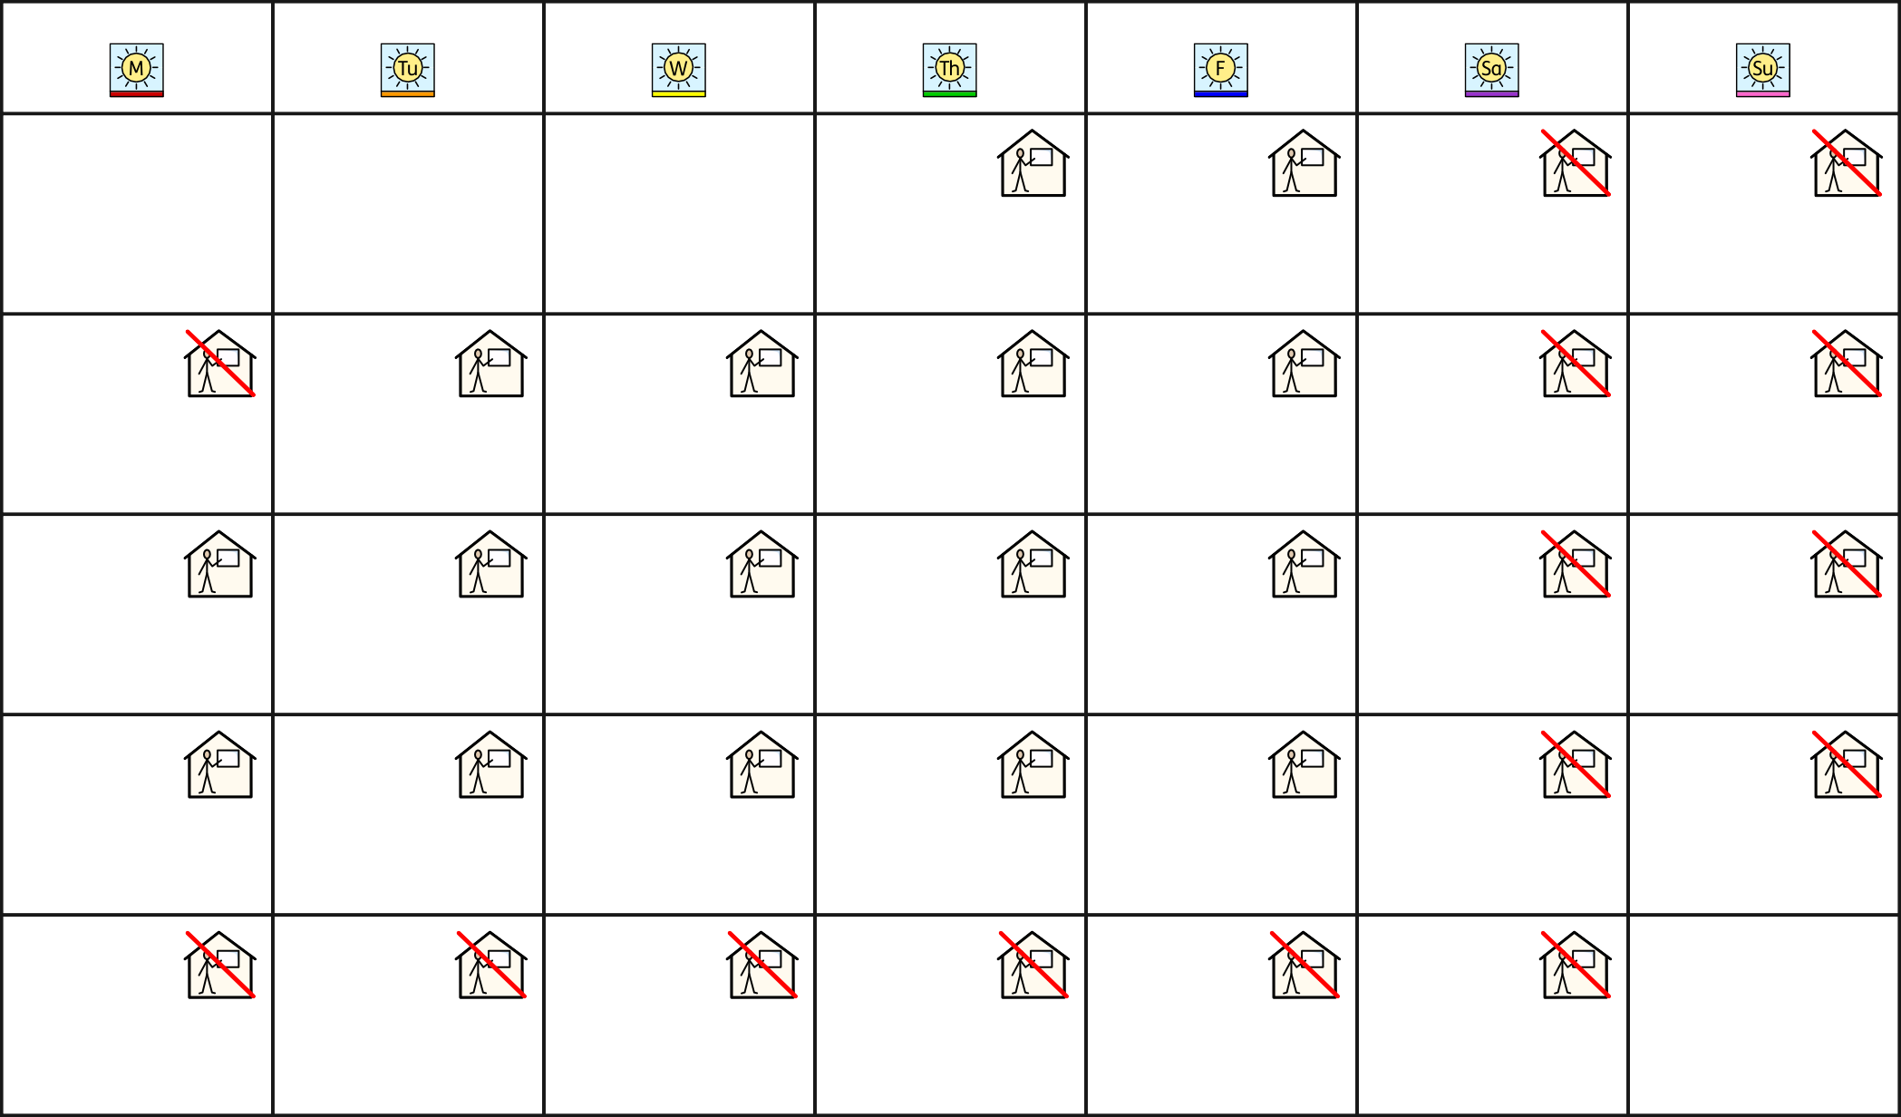May 2025

Monday Tuesday Wednesday Thursday Friday Saturday Sunday

1 2 3 4

5 6 7 8 9 10 11

12 13 14 15 16 17 18

19 20 21 22 23 24 25

26 27 28 29 30 31

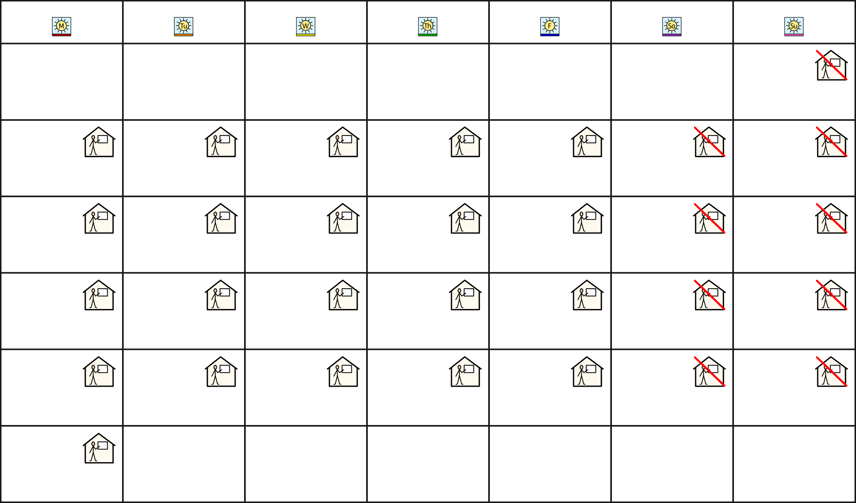June 2025

Monday Tuesday Wednesday Thursday Friday Saturday Sunday

1

2 3 4 5 6 7 8

9 10 11 12 13 14 15

16 17 18 19 20 21 22

23 24 25 26 27 28 29

30

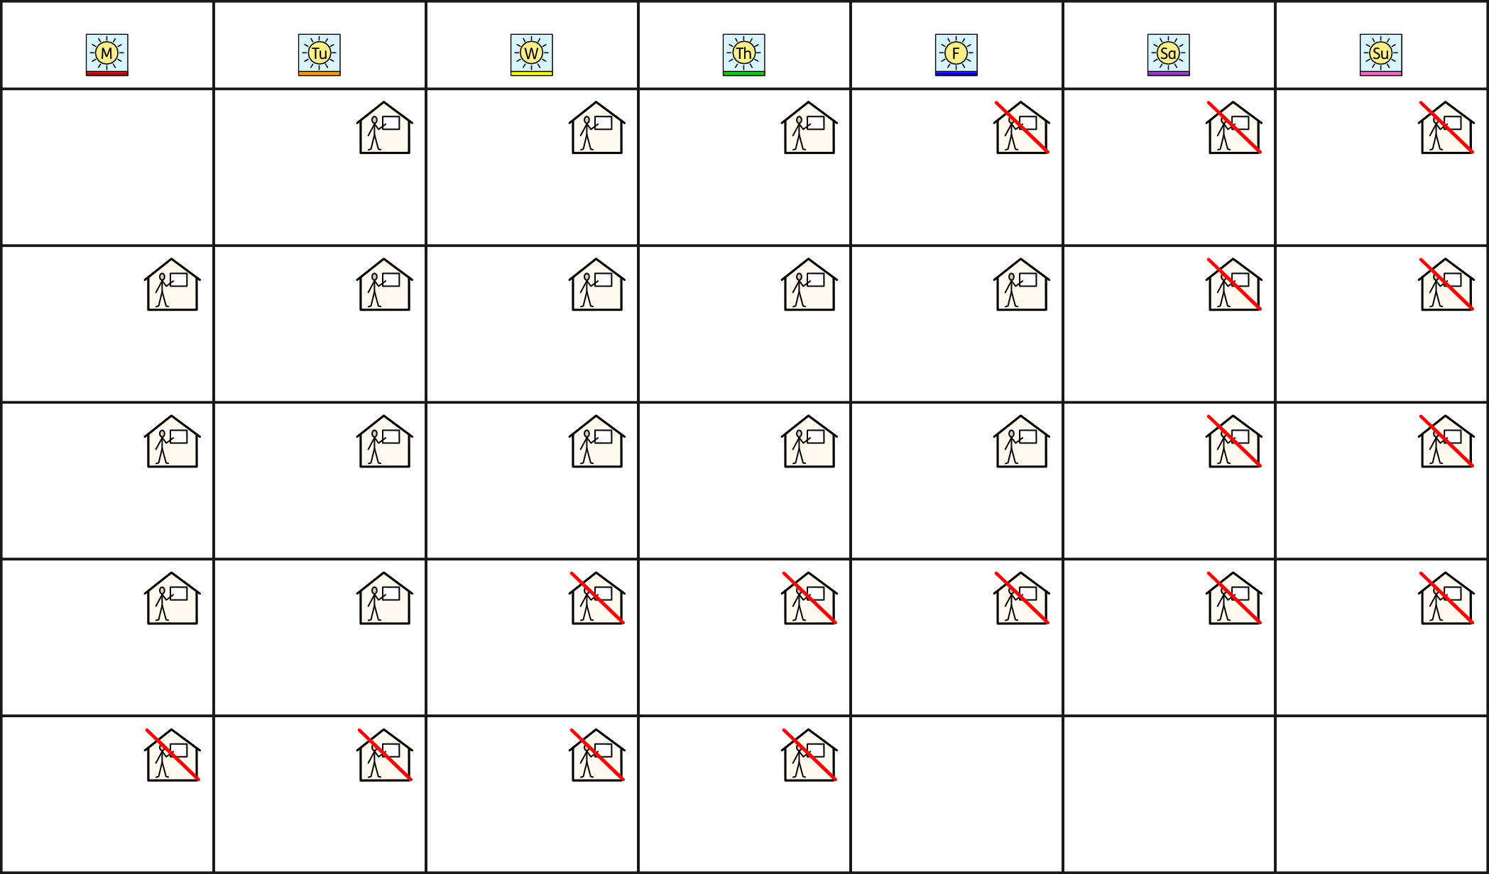July 2025

Monday Tuesday Wednesday Thursday Friday Saturday Sunday

1 2 3 4 5 6

7 8 9 10 11 12 13

14 15 16 17 18 19 20

21 22 23 24 25 26 27

28 29 30 31

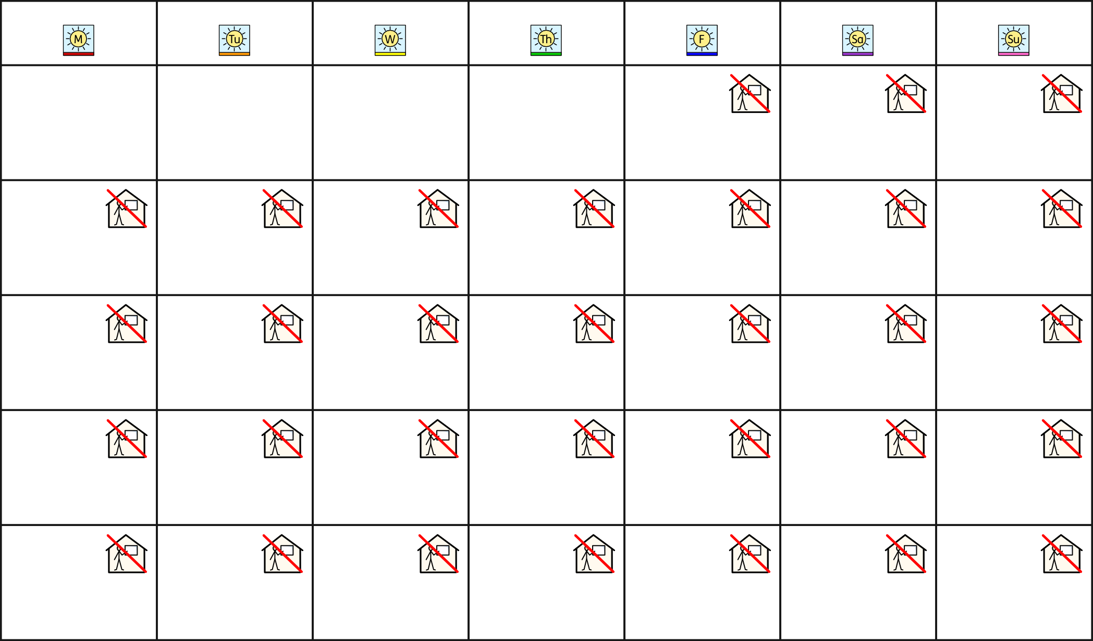August 2025

Monday Tuesday Wednesday Thursday Friday Saturday Sunday

1 2 3

4 5 6 7 8 9 10

11 12 13 14 15 16 17

18 19 20 21 22 23 24

25 26 26 28 29 30 31